Korean Development – Where/When/ and Why?

Kelly Swanson
Johnson Senior High School, St. Paul, Minnesota
Metropolitan State University, St. Paul, Minnesota
kelly.swanson@spps.org

Kelly Swanson has taught geography at Johnson Senior High School for the past 18 years including the first AP Human Geography course in the state of Minnesota. He is a community faculty member at Metropolitan State University in St. Paul, Minnesota teaching the Introduction to Geography Course since 2010.
In 1997, Kelly was selected as a group of educators to establish curriculum for the course. His publishing work has included every edition of the Kaplan AP Human Geography Guide and being the Geographic Advisor to the Onion’s publication of Our Dumb World among other publications.
Kelly has given geographic presentations around the world including collaborating with teachers in India, South Korea, and Japan working on lesson plans related to geographic content and the AP Human Geography course. In addition, Kelly was on the standards committee for the state of Minnesota and assisted in rewriting the 2013 revised geography standards for the state of Minnesota.
Currently, he is working on his doctorate at the University of Minnesota specializing in geography assessment work and was an integral part of the Minnesota Assessment Development Committee, working on establishing a series of assessments aimed at measuring students’ comprehension of the new Minnesota Geography standards.
Mr. Swanson was a member of the delegation in 2009 and gave a paper presentation on Geographic Identity from a Geographic Education Perspective at the 1st International Conference on Territorial and Geographic Education in Seoul, South Korea.

Korean Development – Where/When/ and Why?

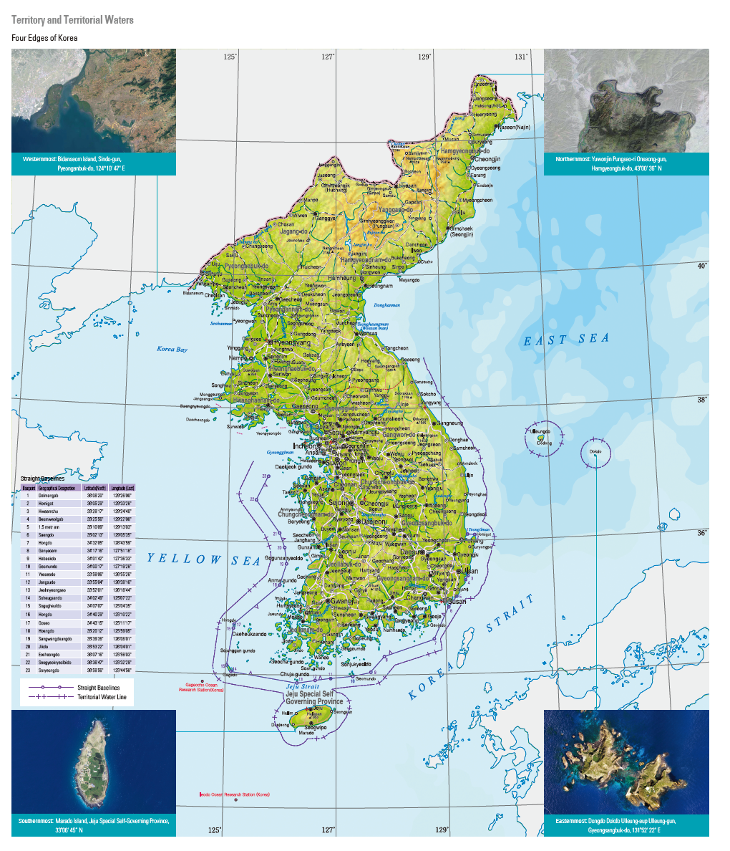

Overview:
Development is a loaded word in geography that can be different at different scales. In this activity, students will be using different indicators of development using the new Korean National Atlas and determine development objectives based on a national and regional scale.

Objectives:
Students will analyze the different indicators of development for their effectiveness and validity using the Korean National Atlas at both the national and regional levels.

Suggested Delivery:

Teacher should have student either write down the indicators of development on their own sheets of paper or use the student worksheet attached to this lesson. The teacher can either print off the maps and use them at different stations or show them in front of the class and have students put the maps/charts into one of the three categories. There are three different indicators of development; economic, social and demographic. Each of these three indicators of development have different statistics that can be used to determine levels of development around the world. For the First part of this activity students should write which map goes in which indicator of development. Upon completion of this the teacher should put up all of the maps again and then students change the scale from a national level to a regional scale analysis. This should show that the economic development is not consistent across all regions of the country and is focused on the Seoul and suburban regions of the primate city.

Social – Education Levels (#5), Leisure Time, Living Environment (#14), Quality of Life Index (#9), Personal Satisfaction Maps (#12)

Demographic – Growth Rates, Sex Ratio/Dependency Ratio Map (#17), Primate City (#8), Depopulated regions (#4), Life Expectancy (#13), Population Change Map (#15), Dependency Ratio 2(#21)

Economic- Accessibility (#1), Agricultural Production and Mineral Map (#2), Declining Industry Map (#3), GDP/Region Map (#6), Industry Types, Infrastructure, Research and Development (#16), Unemployment Rate, Value Added, Wage Levels, Resources and Energy, Per Capita GRDP (#7), Regional Industrial Map (#10), Industrial Production and Infrastructure (#11), Changing Research and Development Map (#18), Share of Employees Map (#19), Transportation Map (#20), Unemployment Rate (#22), CGP and Value Added Charts (#23), Manufacture Value Added Maps (#24), Economically Active Population (#25)

Students should analyze why there are so many indicators within the economic section and demographic section and not a lot within the social section?

1. Accessibility Map:

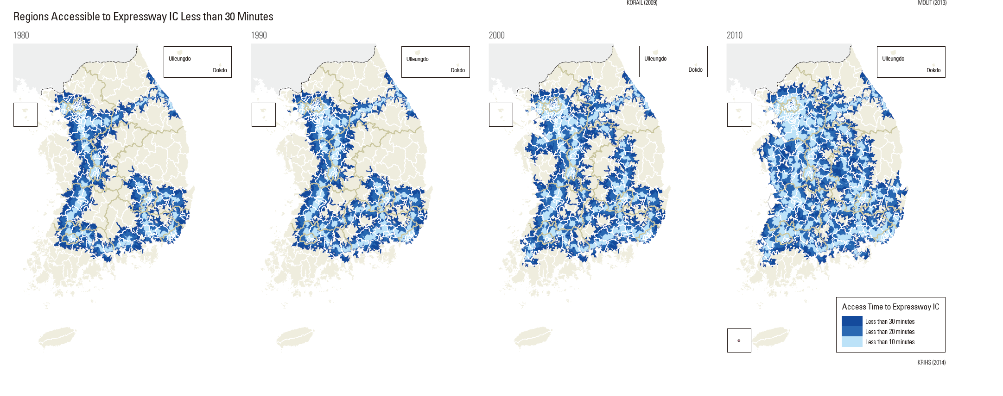

2. Agricultural Production and Mineral Resources Map:

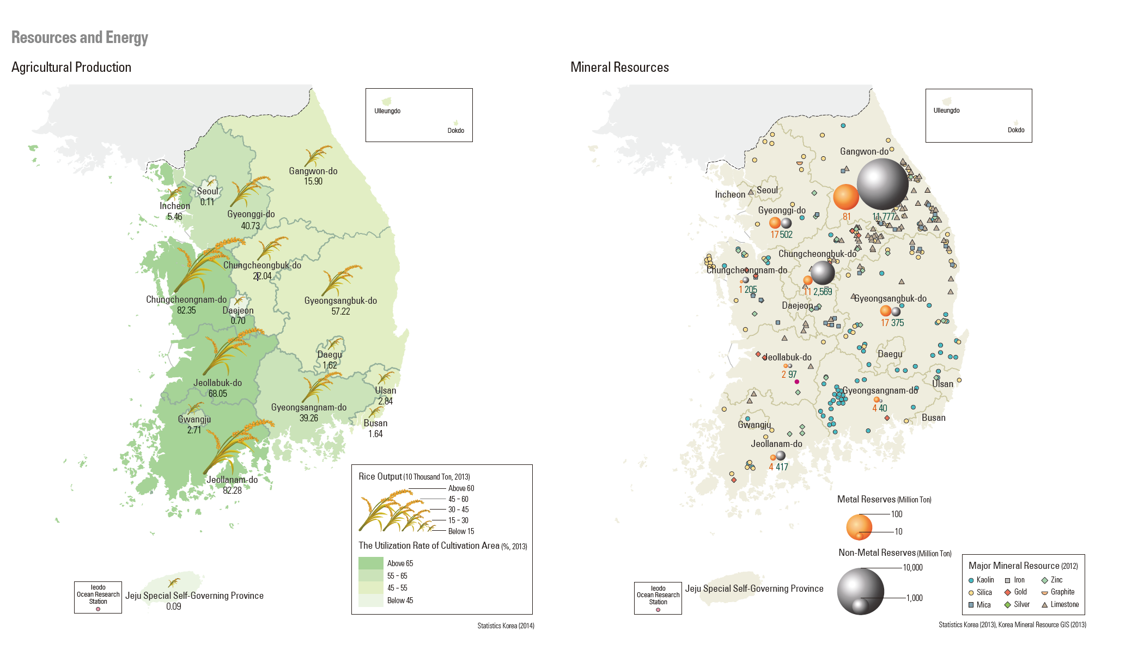

3. Declining Industry Map:

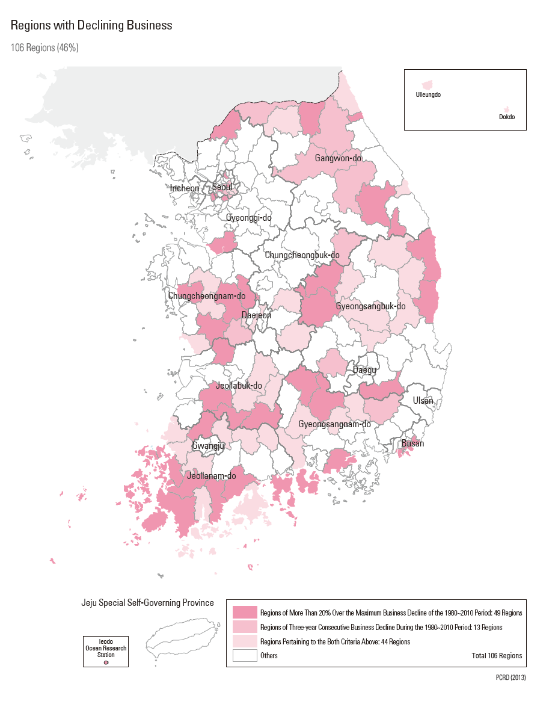

4. Depopulated Regions of Korea:

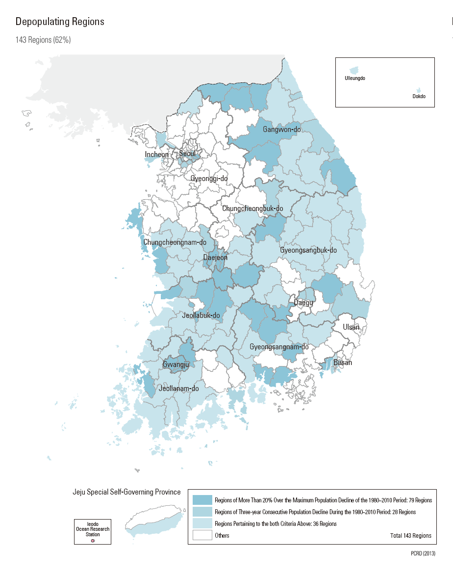

5. Education in Korea:
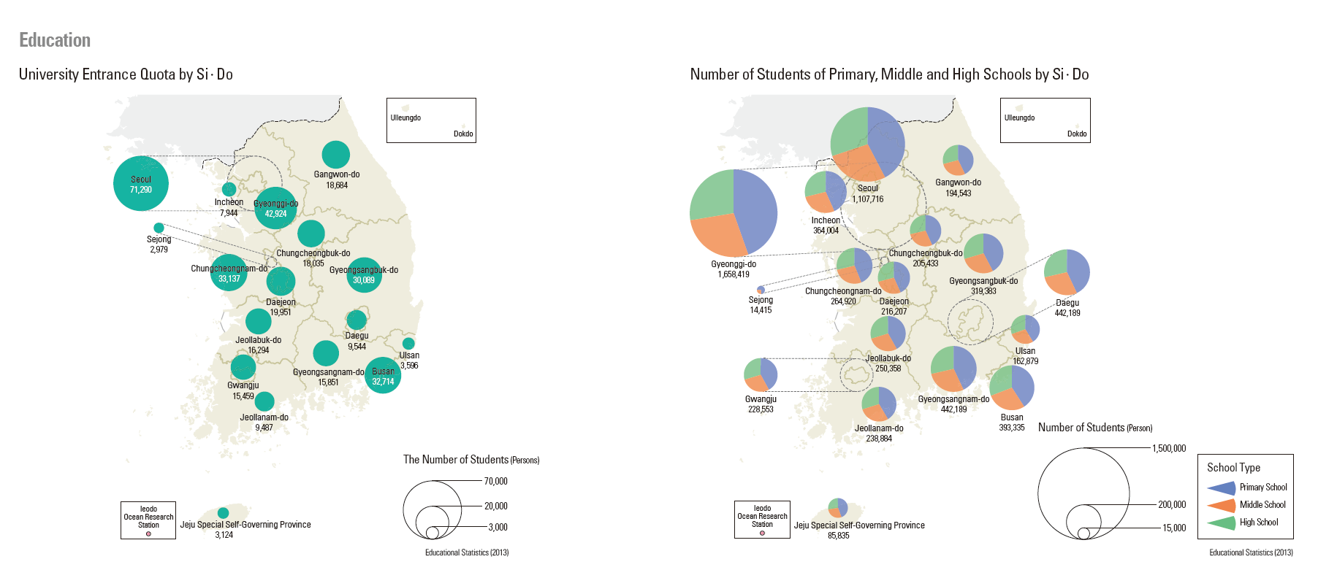

6. Gross Domestic Product by Region
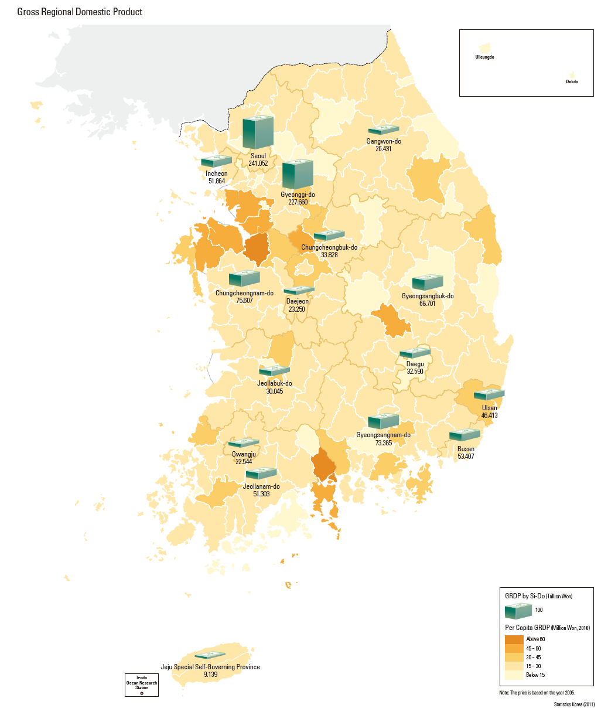

7. Per Capita GRDP and Headquarters of Major Corporations:

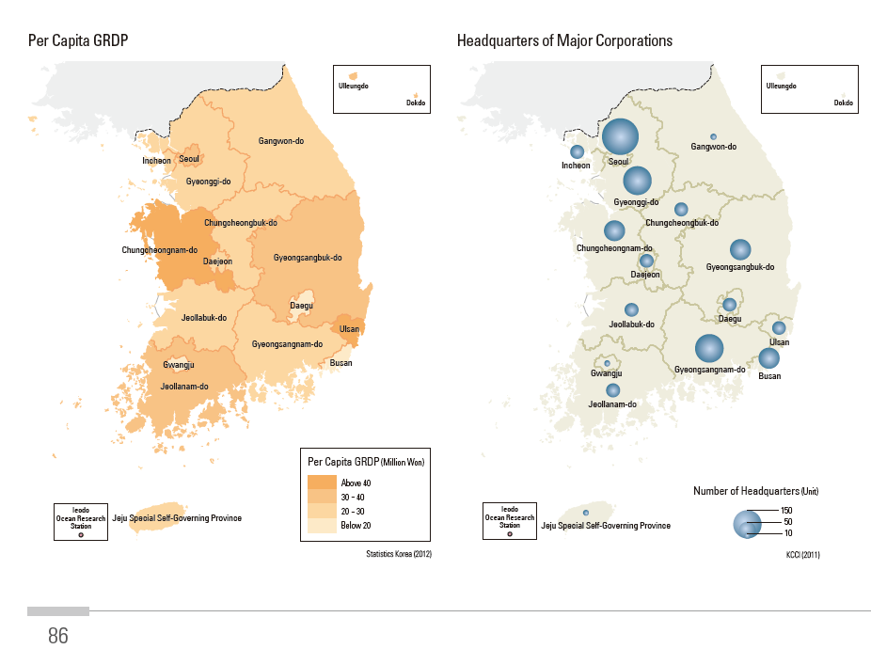

8. Primate City – Population Map
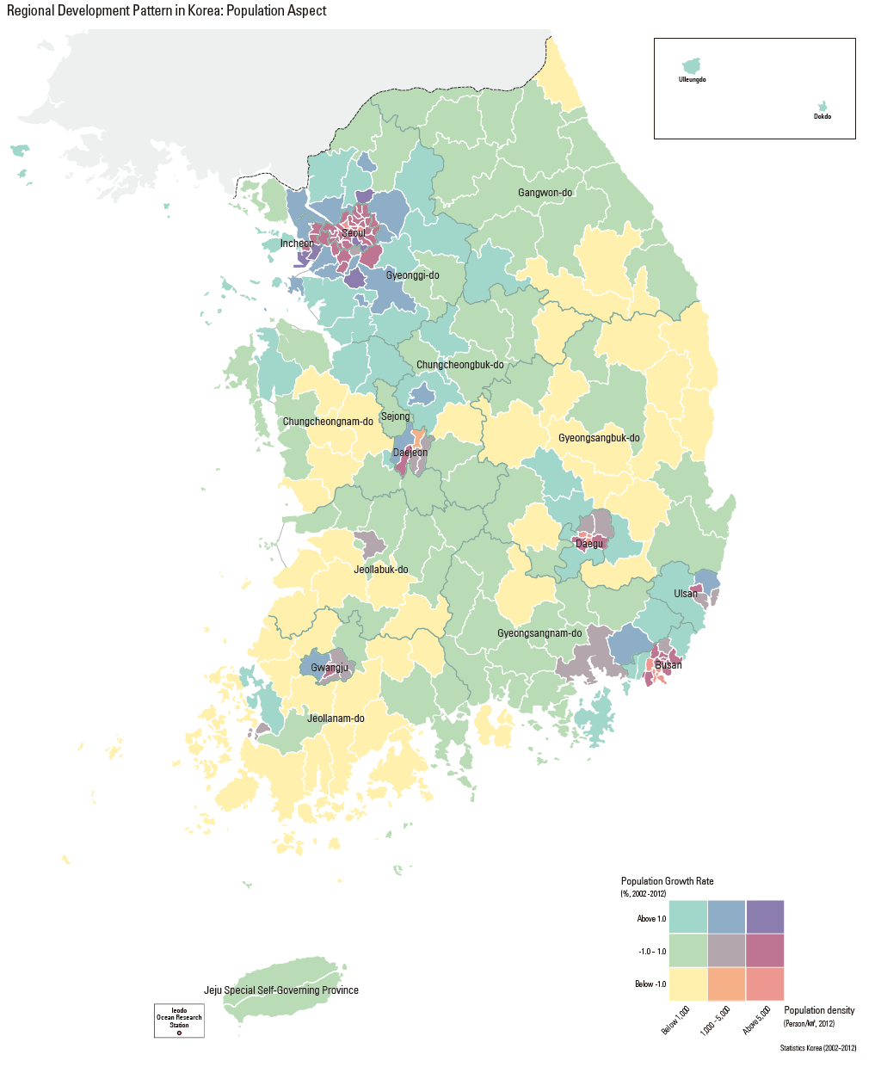

9. Quality of Life Index:
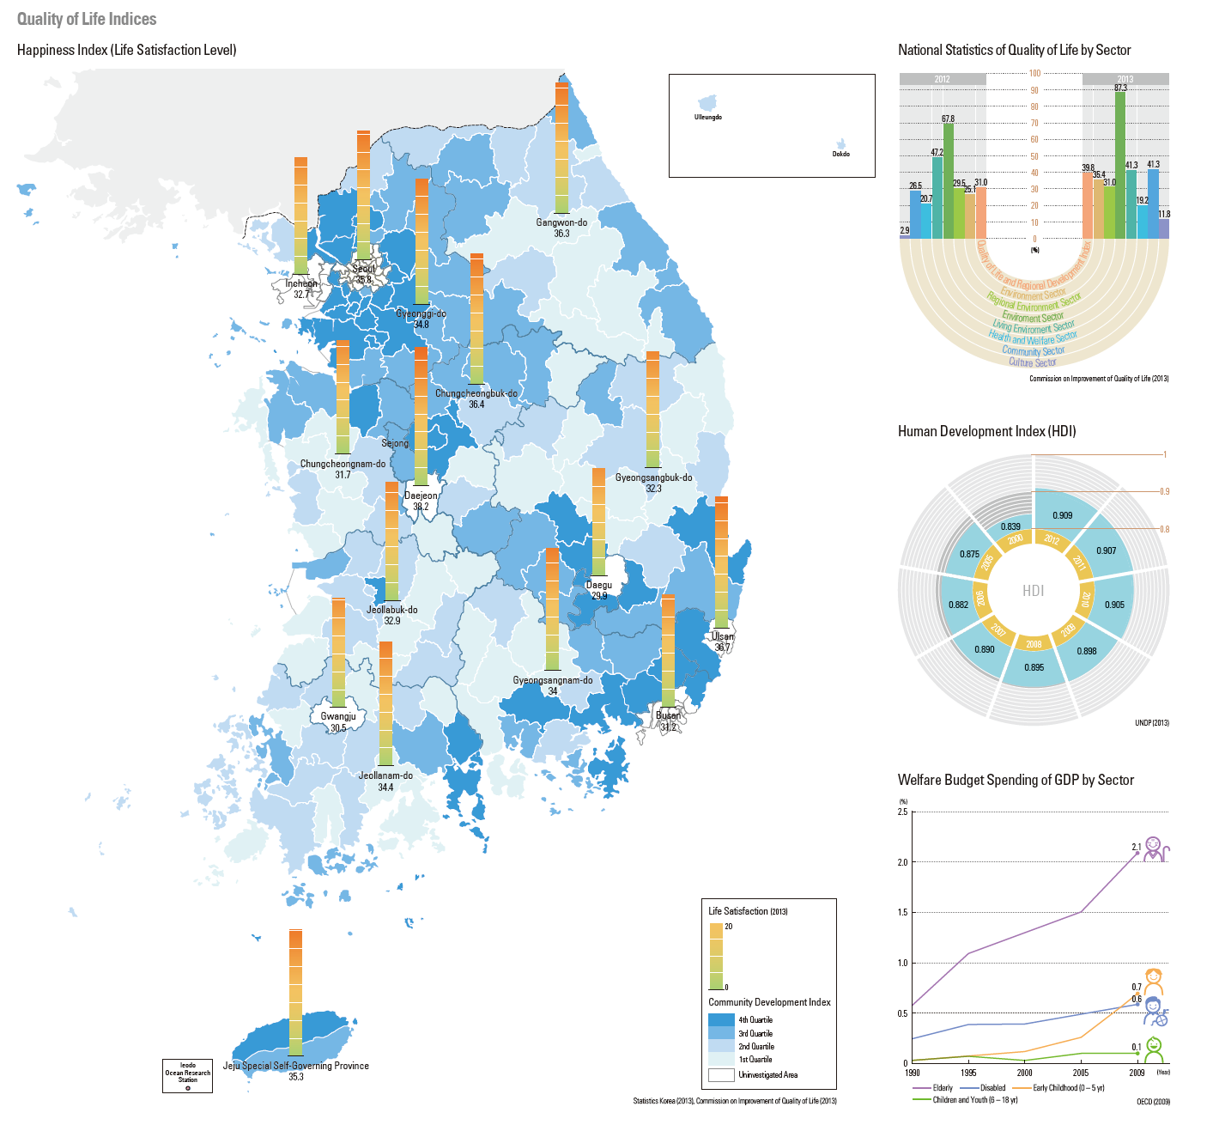

10. Regional Industrial Map:

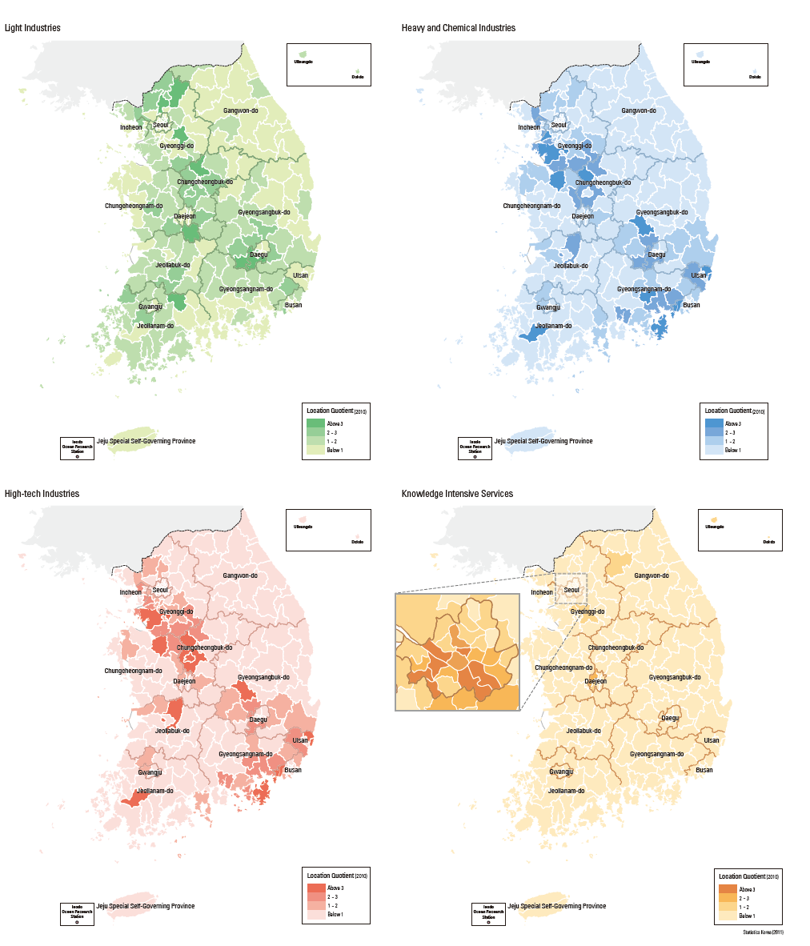

11. Industrial Production and Infrastructure Investment:
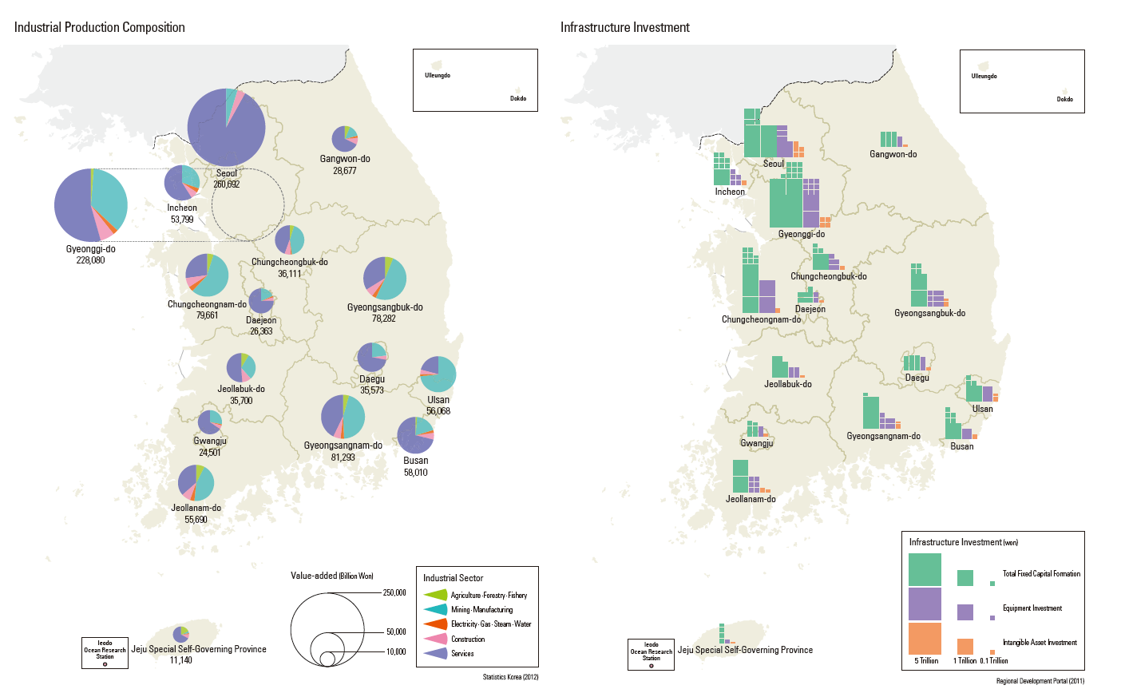

12. Personal Satisfaction Maps:
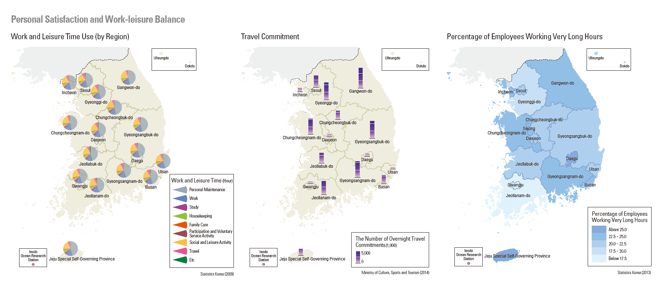

13. Life Expectancy:

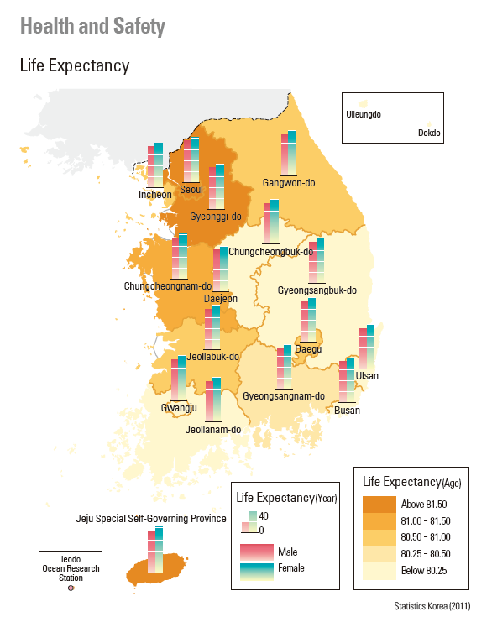

14. Living Environment Map (Parks):
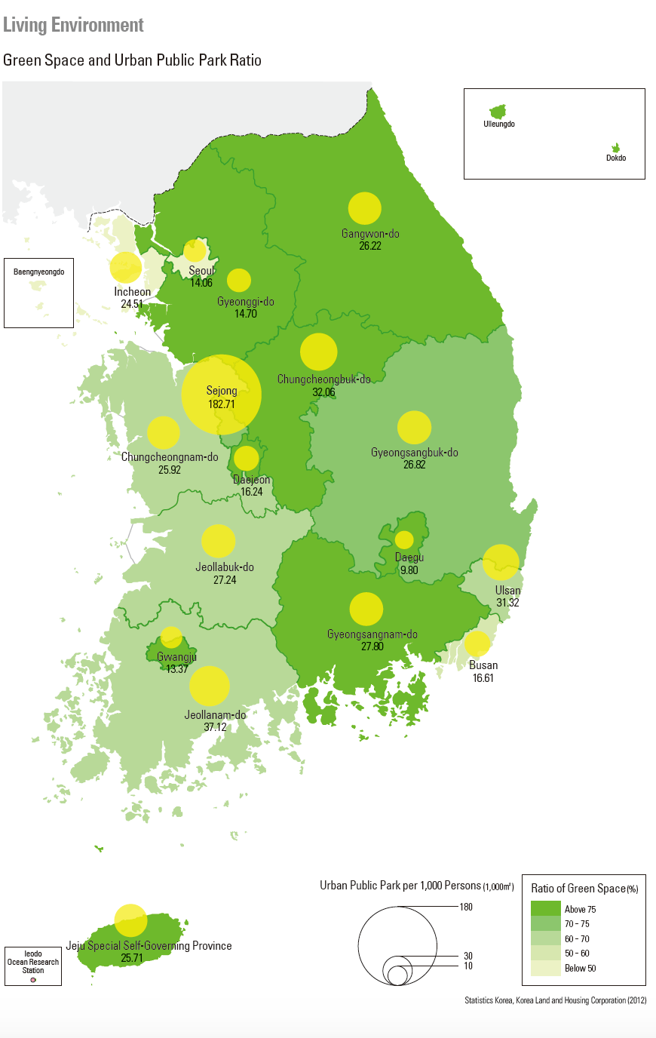

15. Population Change Map:
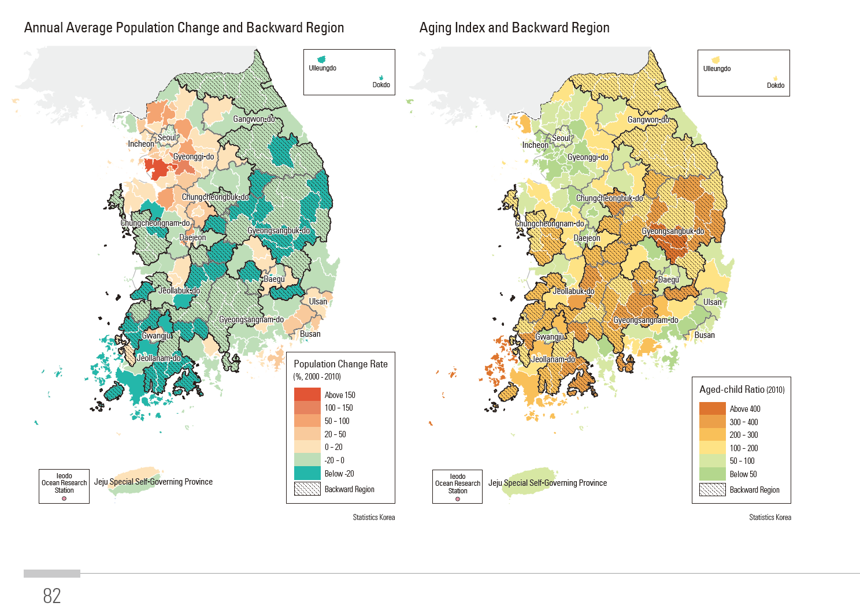

16. Research and Development Investment Map and Firms:
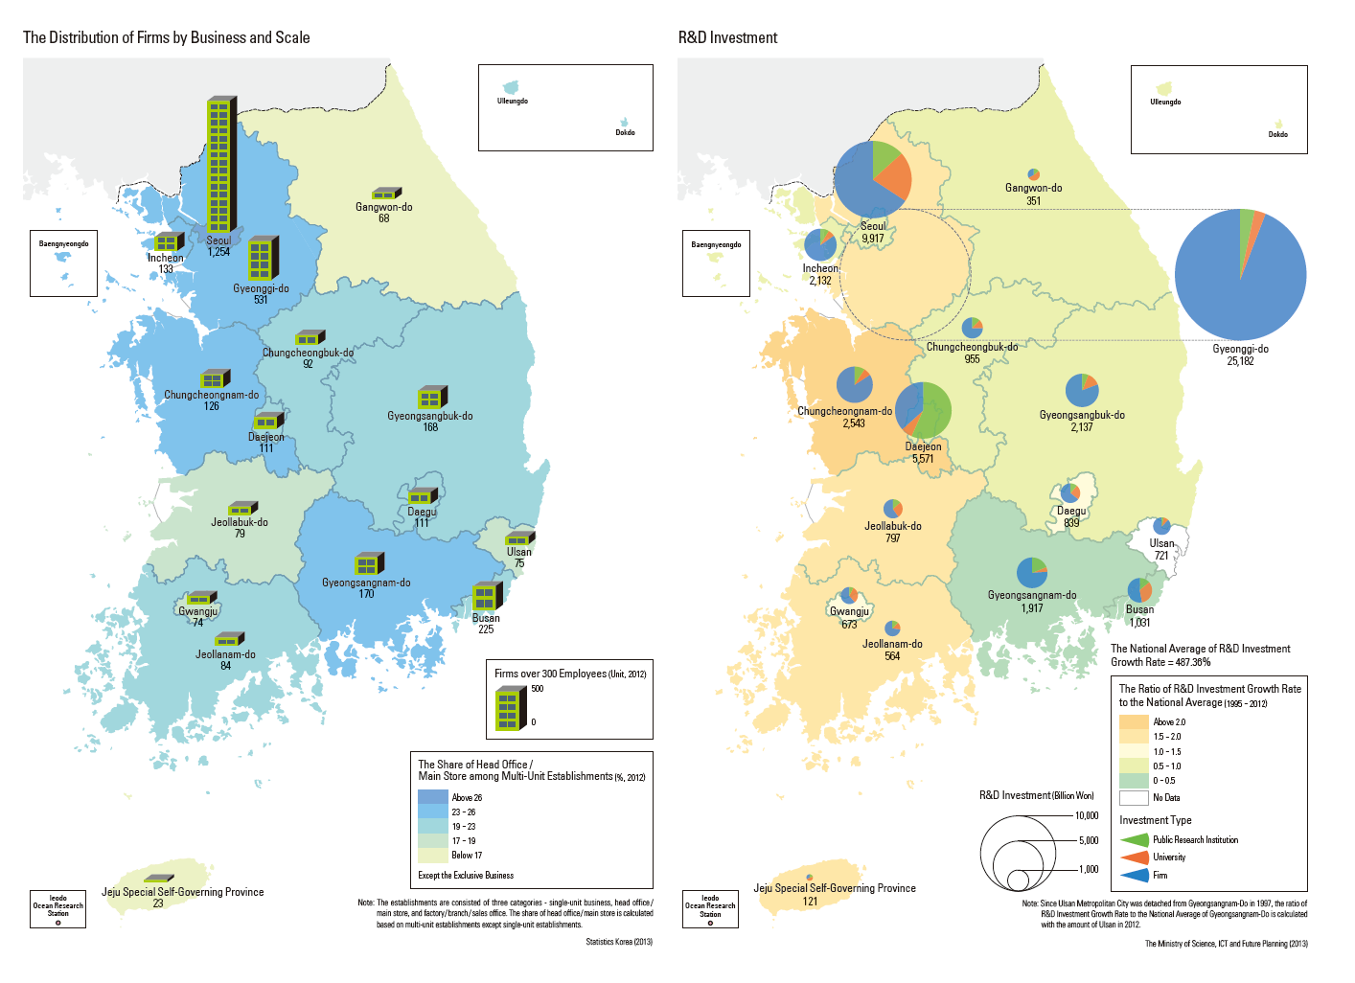

17. Sex Ratio/Dependency Ratio Maps:
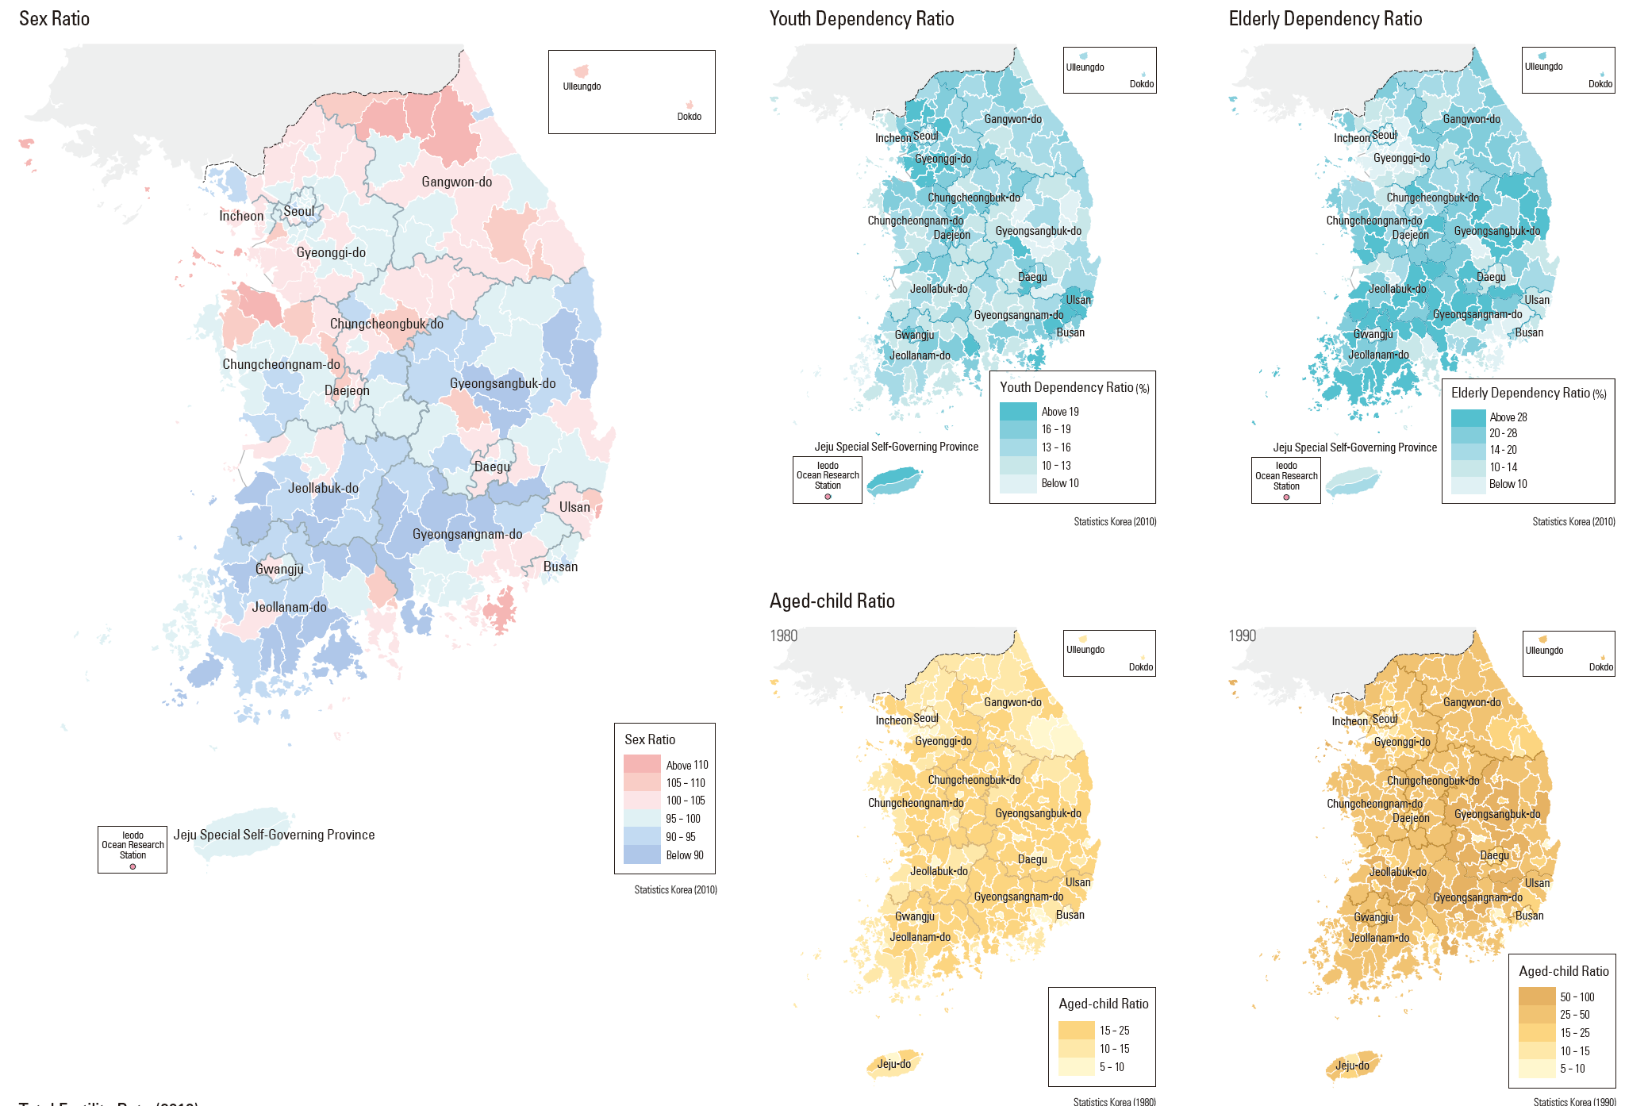

18. Research and Development Map:
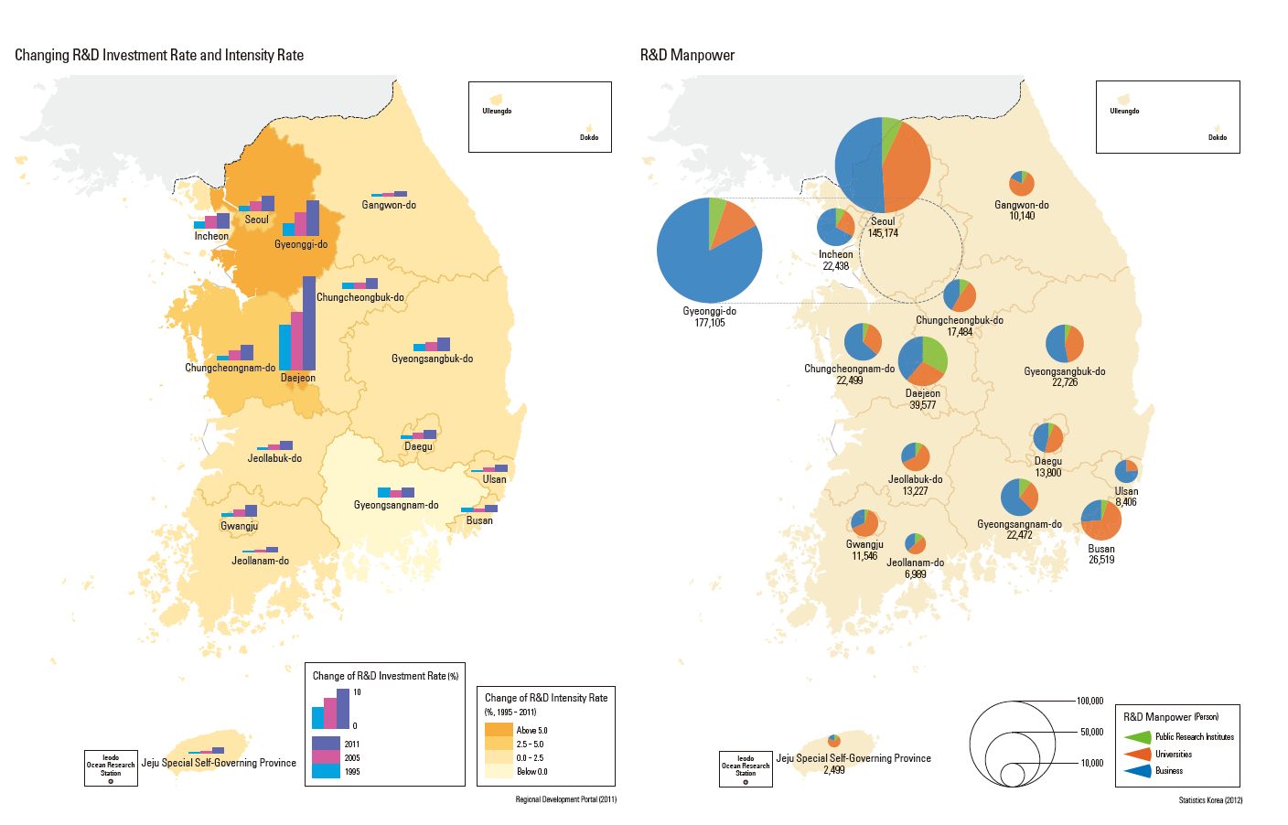

19. Share of Employees Map:
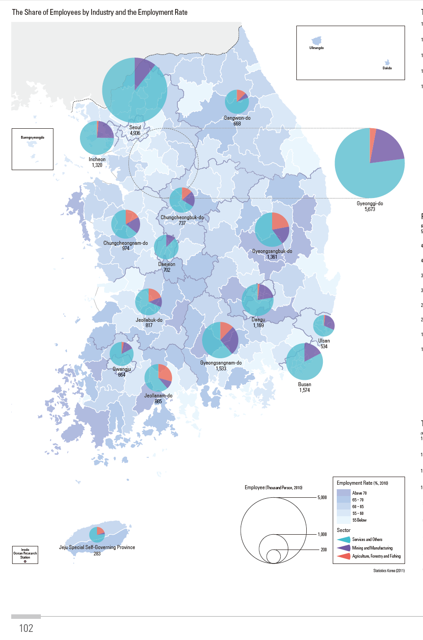

20. Transportation Map:

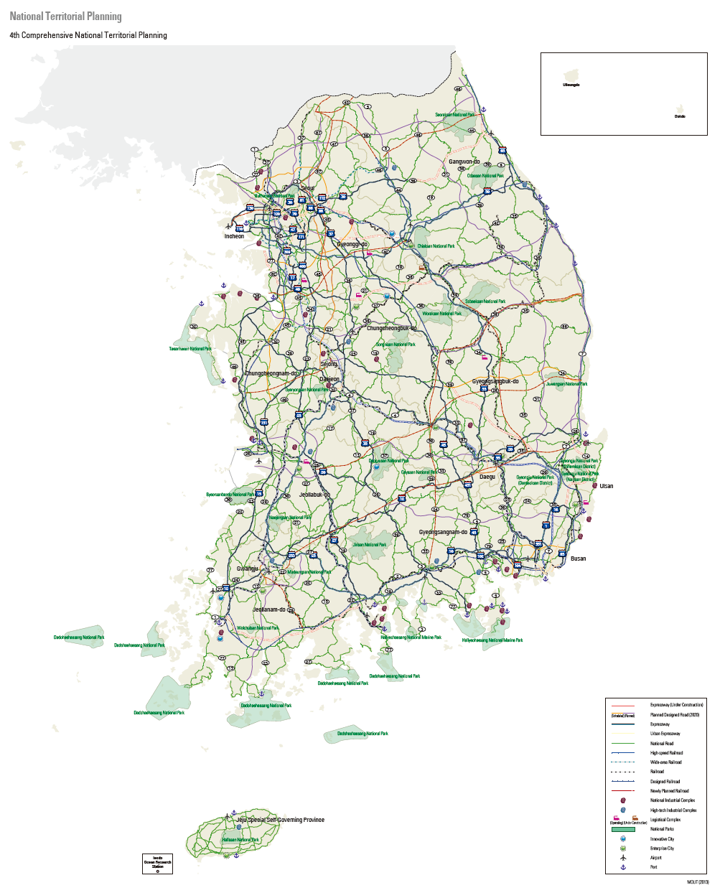

21. Total Dependency Ratio Map:
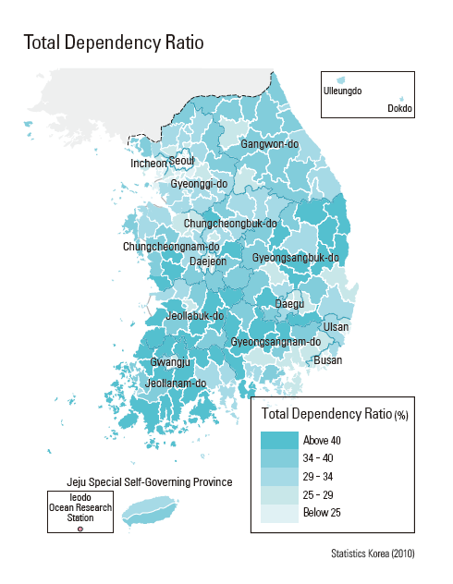

22. Unemployment Rate:

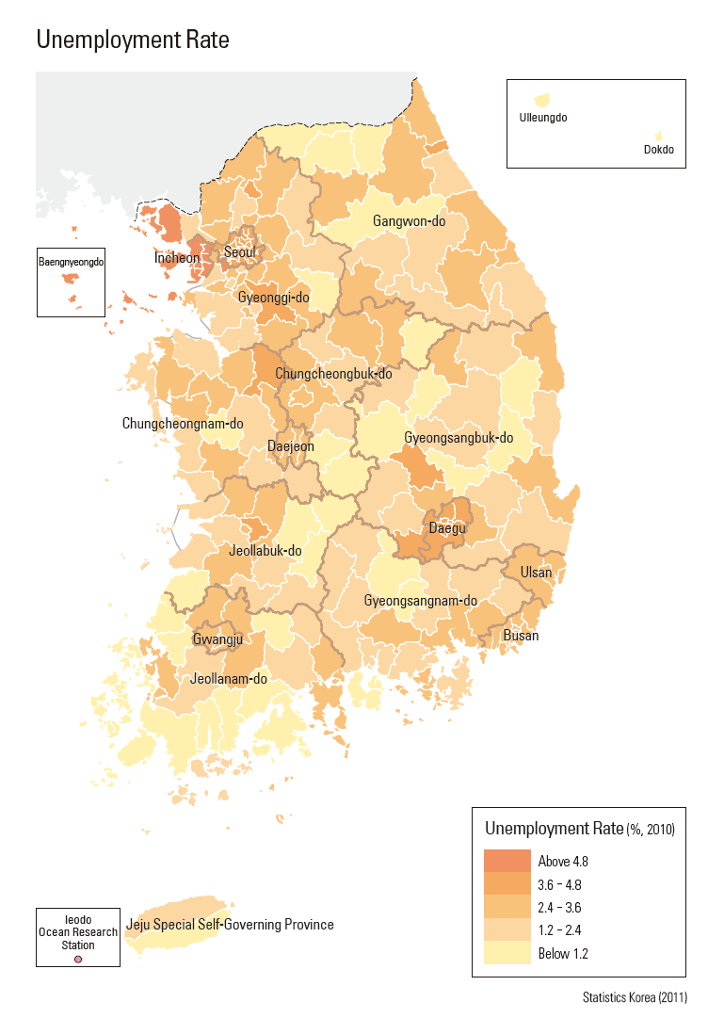

23. GDP and Value Added Chart:
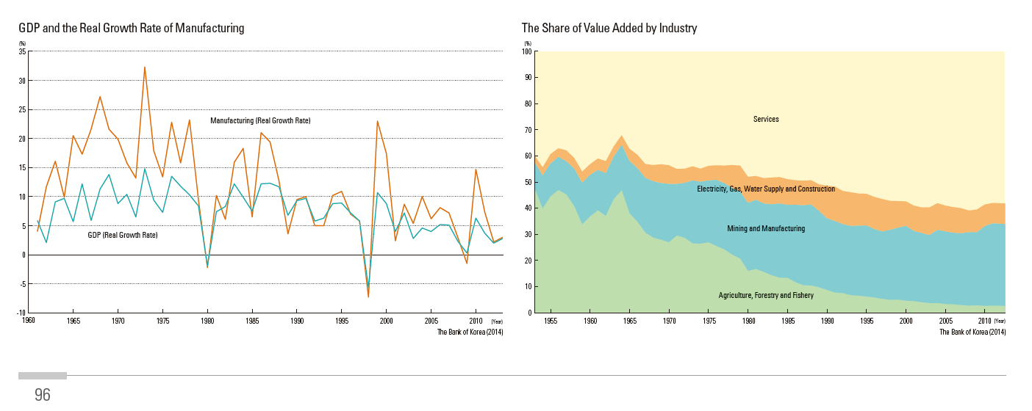

24. Value Added By Industrial Sector:
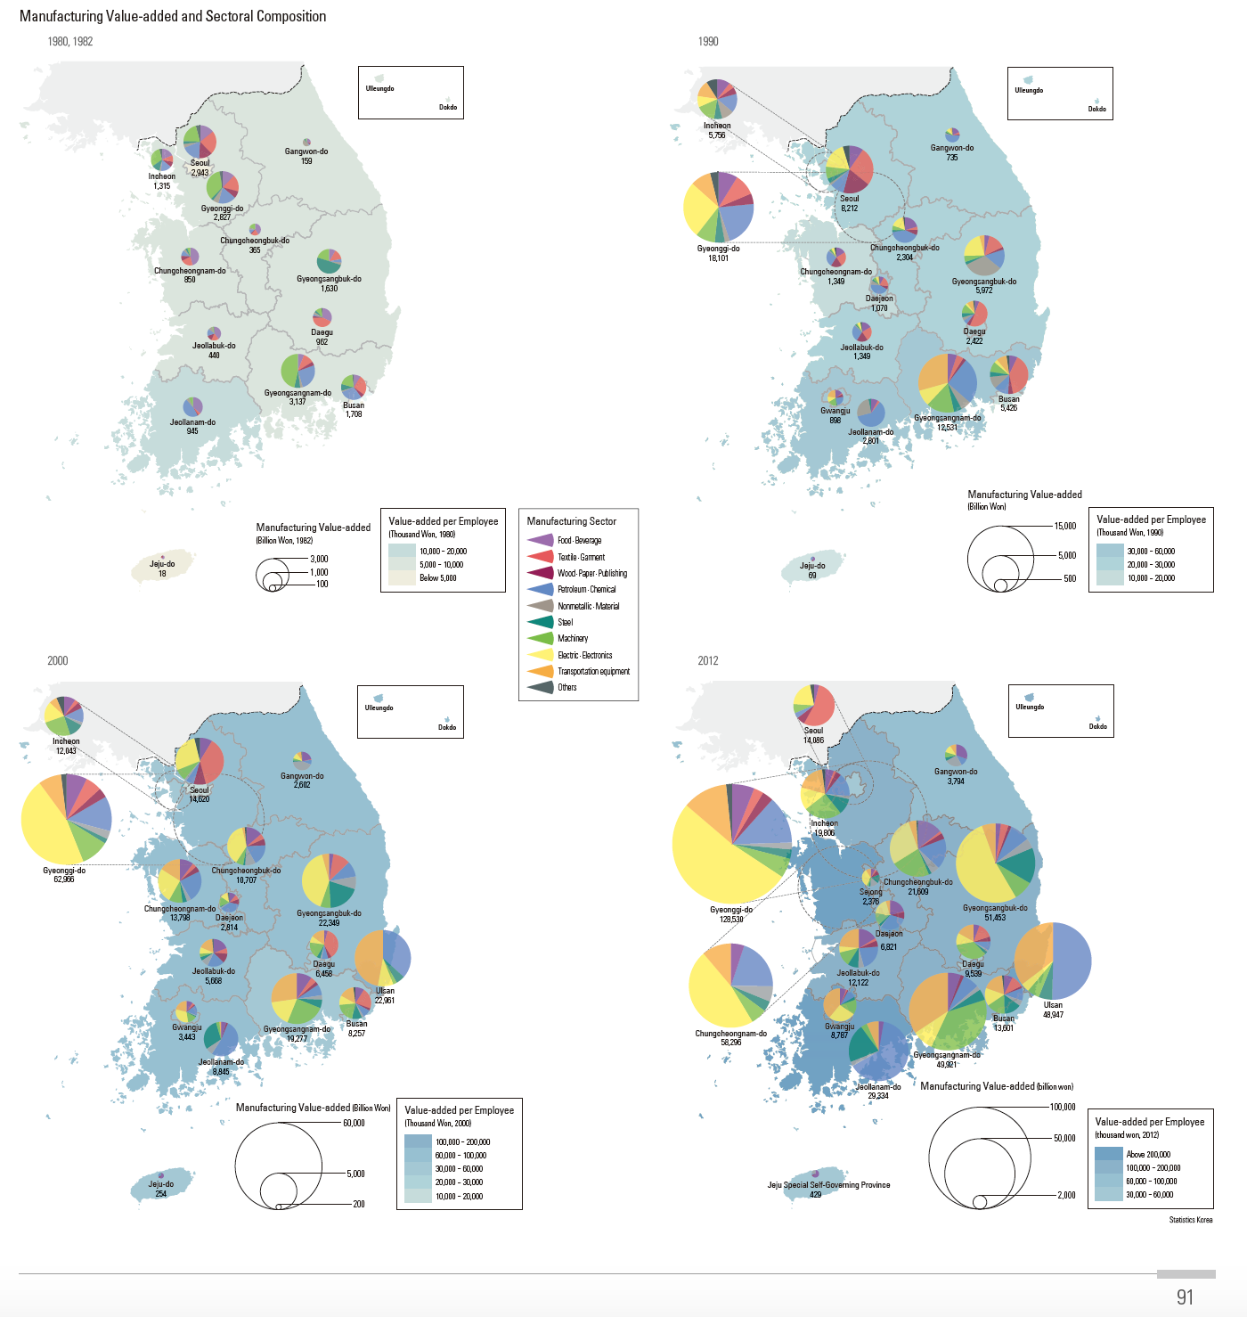

25. Structure of Economically Active Population and Wage Level Maps:
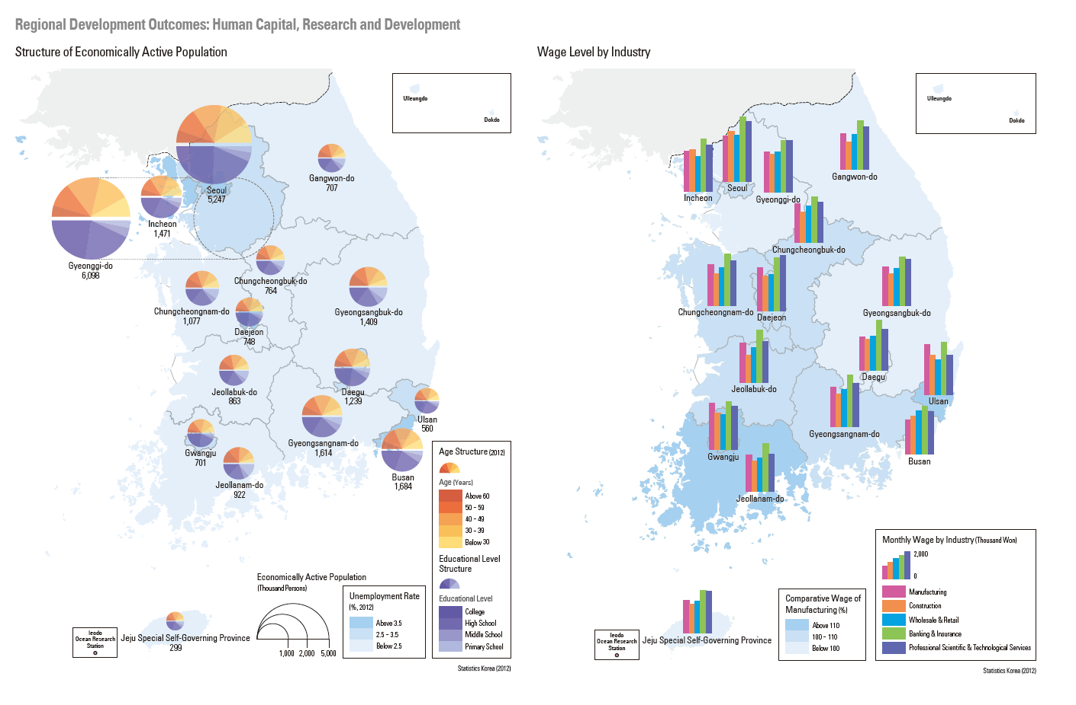

Student Activity Chart:

Social Indicators of Development:
1.
2.
3.
4.
5.
6.
7.
8.

Demographic Indicators of Development:
1.
2.
3.
4.
5.
6.
7.
8.
9.
10.

Economic Indicators of Development:
1.
2.
3.
4.
5.
6.
7.
8.
9.
10.
11.
12.
13.
14.
15.

Part II
Changing Scales:

Students should select upwards of five maps and explain the regional distribution of development. Which maps did the students select to determine development and why? What does this suggest about the regions that are developing and are developed? Students should answer this section in a paragraph/essay format.

The students should write up their maps content in an essay format. The rubric at the conclusion of this lesson should be used to determine student knowledge.

Students should see that although Korea is a developed state on a national scale, there are areas of the country that are not as developed as the Seoul metropolitan region. The primate city has the majority of investment in the country as well as infrastructure. Other areas of the country remain relatively isolated even from major transportation routes. This may be in part to the physical topography of the Korean peninsula, which only has about 22% of its land arable for farming practices. Scale is important when determining economic, social, and demographic development.

