Rice is Nice!
The Why of Where of Korean and American Rice Production

Author:
Kelly Swanson
Johnson Senior High School
Metropolitan State University
St. Paul, Minnesota

Overview:
Students will be analyzing areas of rice production in the United States and Korea. When comparing the two areas, students will use Google Earth to evaluate the latitude and longitude of the different areas of rice production in both countries. Both countries have rice production around the 30 degrees north parallel.

Other data in the lesson indicates a reduction in the acreage of rice planted but more harvest. This is due to trade agreements with other countries to import rice. Even as rice decreases in the typical Korean diet and being replaced by more protein such as meat, rice production has increased in the country do to the efficiency of farmers around the country.

As farmers are growing less rice, they are growing more fruits and vegetables which means higher profit margins for Korean farmers. This process of converting from rice to fruits and vegetables is known as the White Revolution in Korea as the plastic tarps have taken over many fields to protect the more expensive crops.

Objectives:
Students will analyze the rice production areas and trends of Korean and American rice production.

National Standards:
Standard #1:
How to use maps and other geographic representations, tools, and technologies to acquire, process, and report information form a spatial perspective.

Standard #3:
How to analyze the spatial organization of people, places, and environments on Earth’s surface.
Standard #11:
The patterns and networks of economic interdependence on Earth’s surface.

Standard #14:
How human actions modify the physical environment.

Suggested Delivery:

- Show students the pictures from the attached PP which have all of the resources attached.
- After showing the maps of rice production in the United States and Korea, students should find a rice field in each country on Google Earth.
- Placemark or write down the latitude of their rice field. Many of the rice fields in both countries will be along the 30 degree north.
- Students should find vegetable production in California and in Korea. Look for the white tarps covering the fields in Korea. Pictures can be found in the attached PP.
- What is common about the rice fields? (flooded fields for irrigation).
- What impact does rice production have on areas around the flooded fields?
- What is happening to rice consumption in Korea? (It is decreasing and being replaced with more of a protein diet.)
- Which state has rice as its most lucrative crop? (Arkansas)
- Even though rice is grown in both Arkansas and California, why isn’t rice as productive as other crops? (More money can be made on bulkier fruit and vegetable crops)
- How does this fit in with von Thunen’s model of agricultural land use? (Farmer wish to maximize their profits by growing more fruits and vegetables on their land over the less profitable rice crops.)

Resource #1

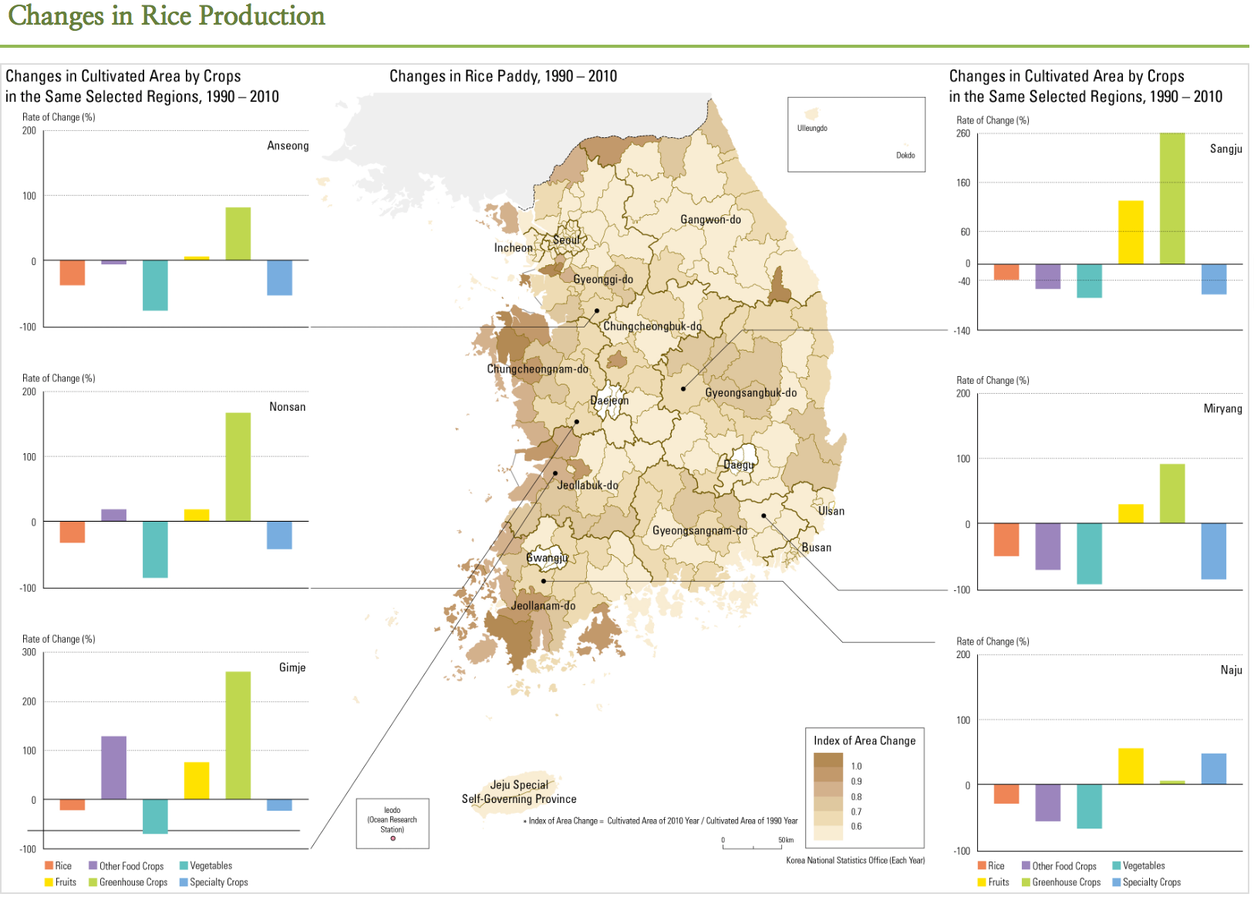

Resource #2

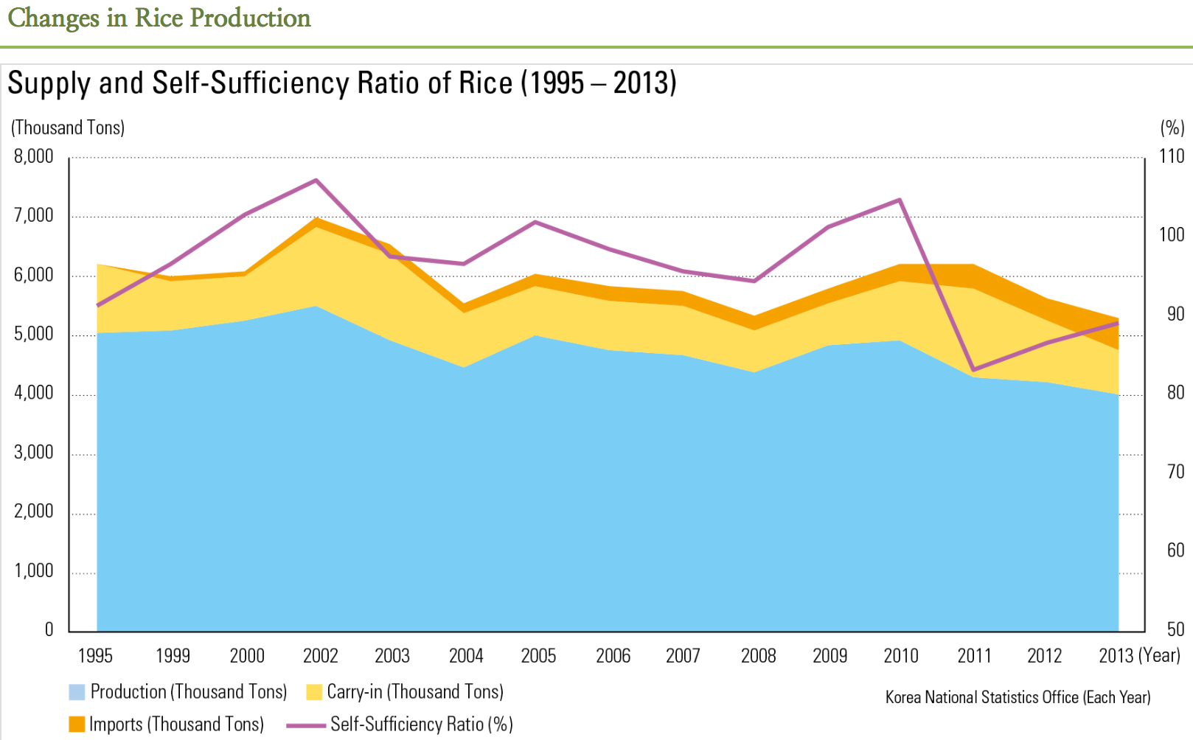

Resource #3

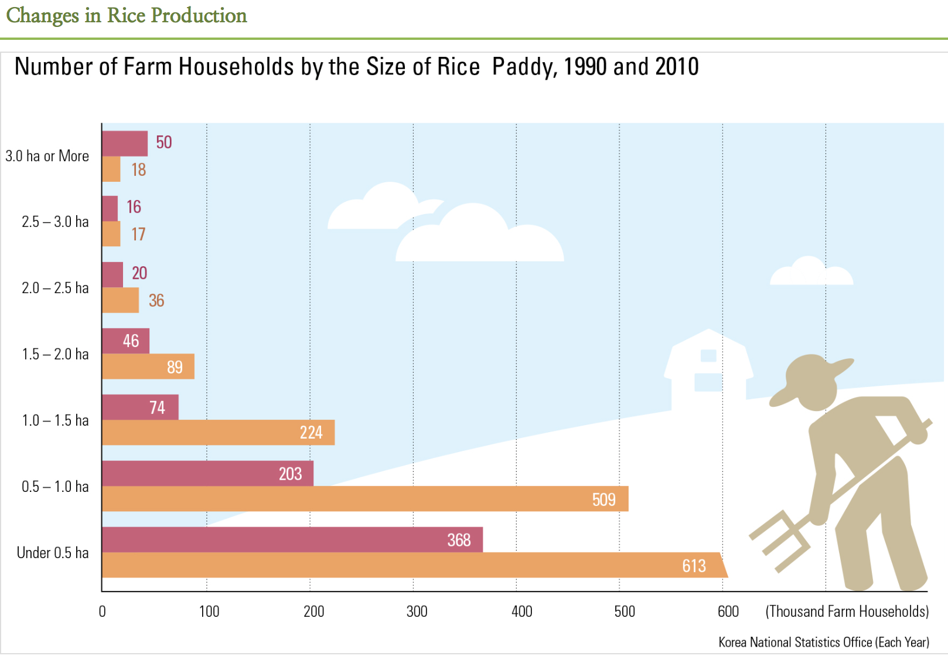

Resource #4

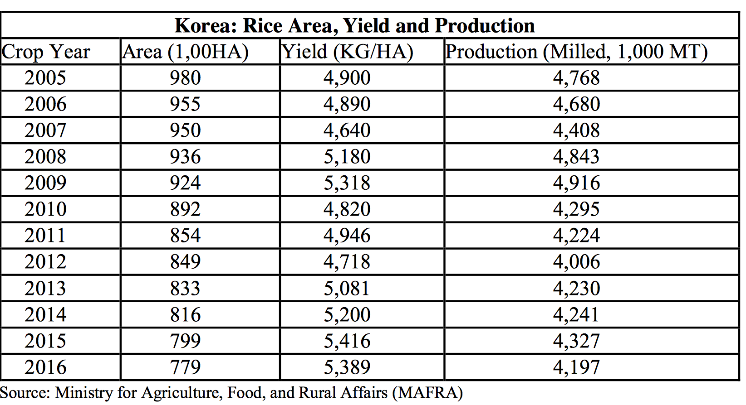

Resource #5:

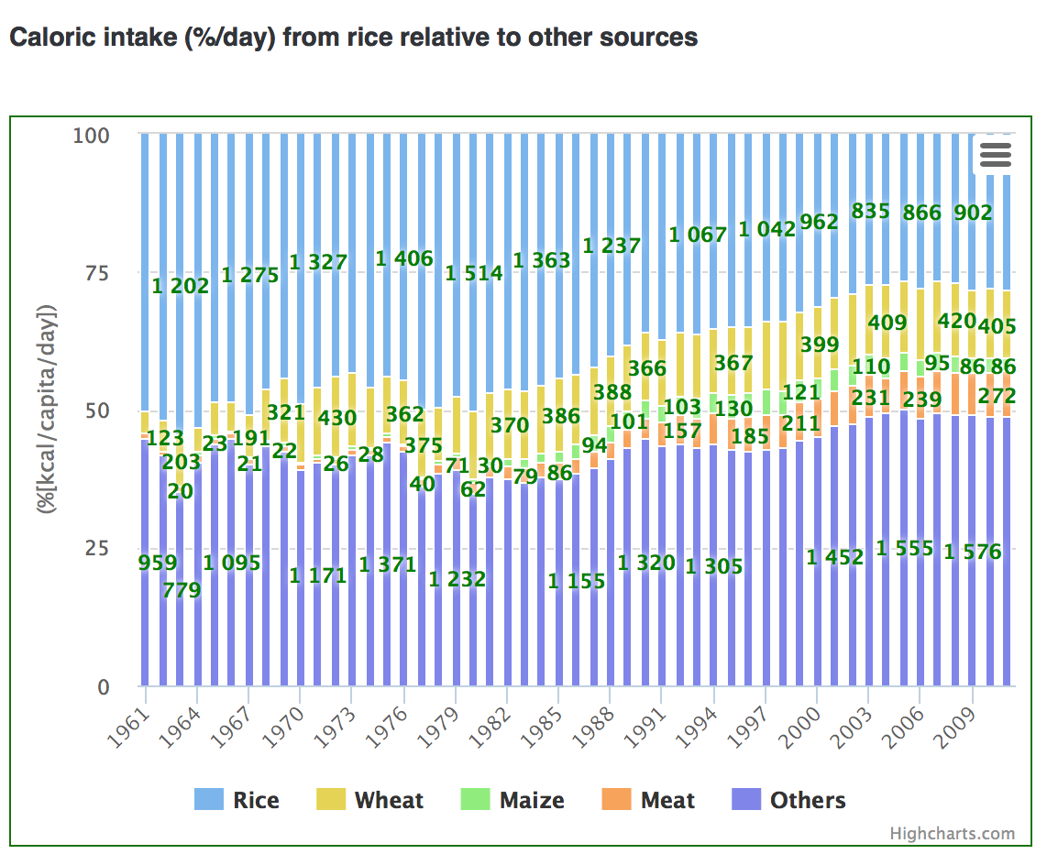

Resource #6

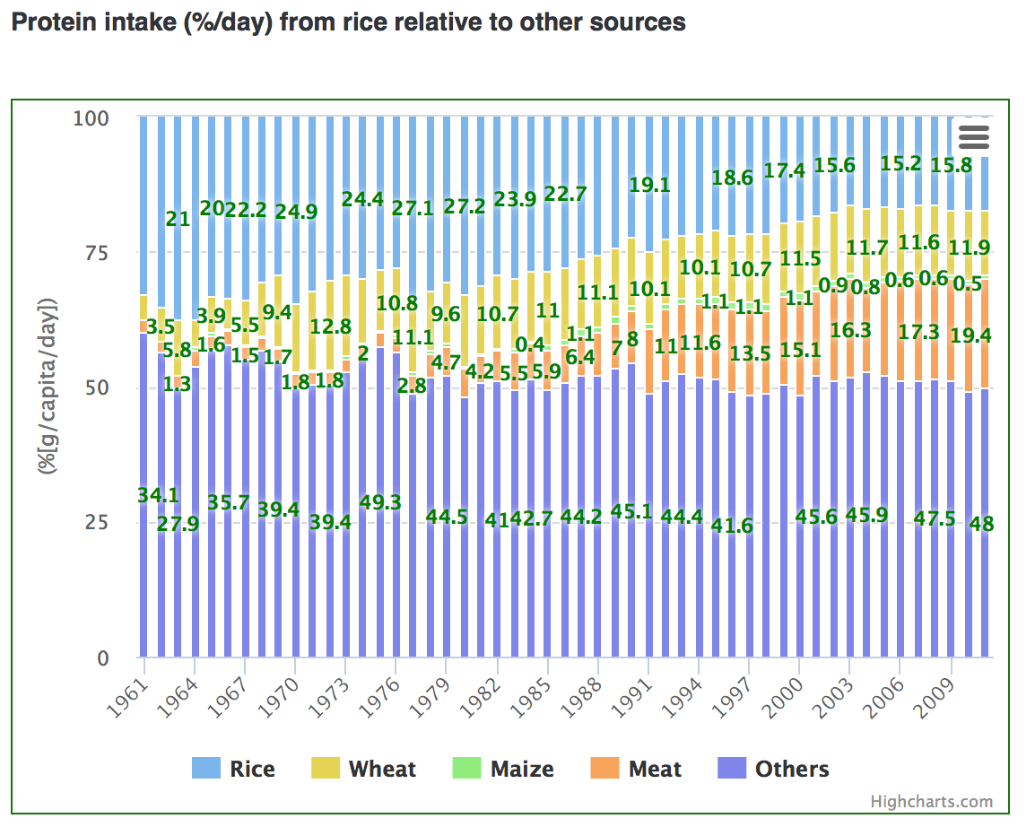

Resource #7

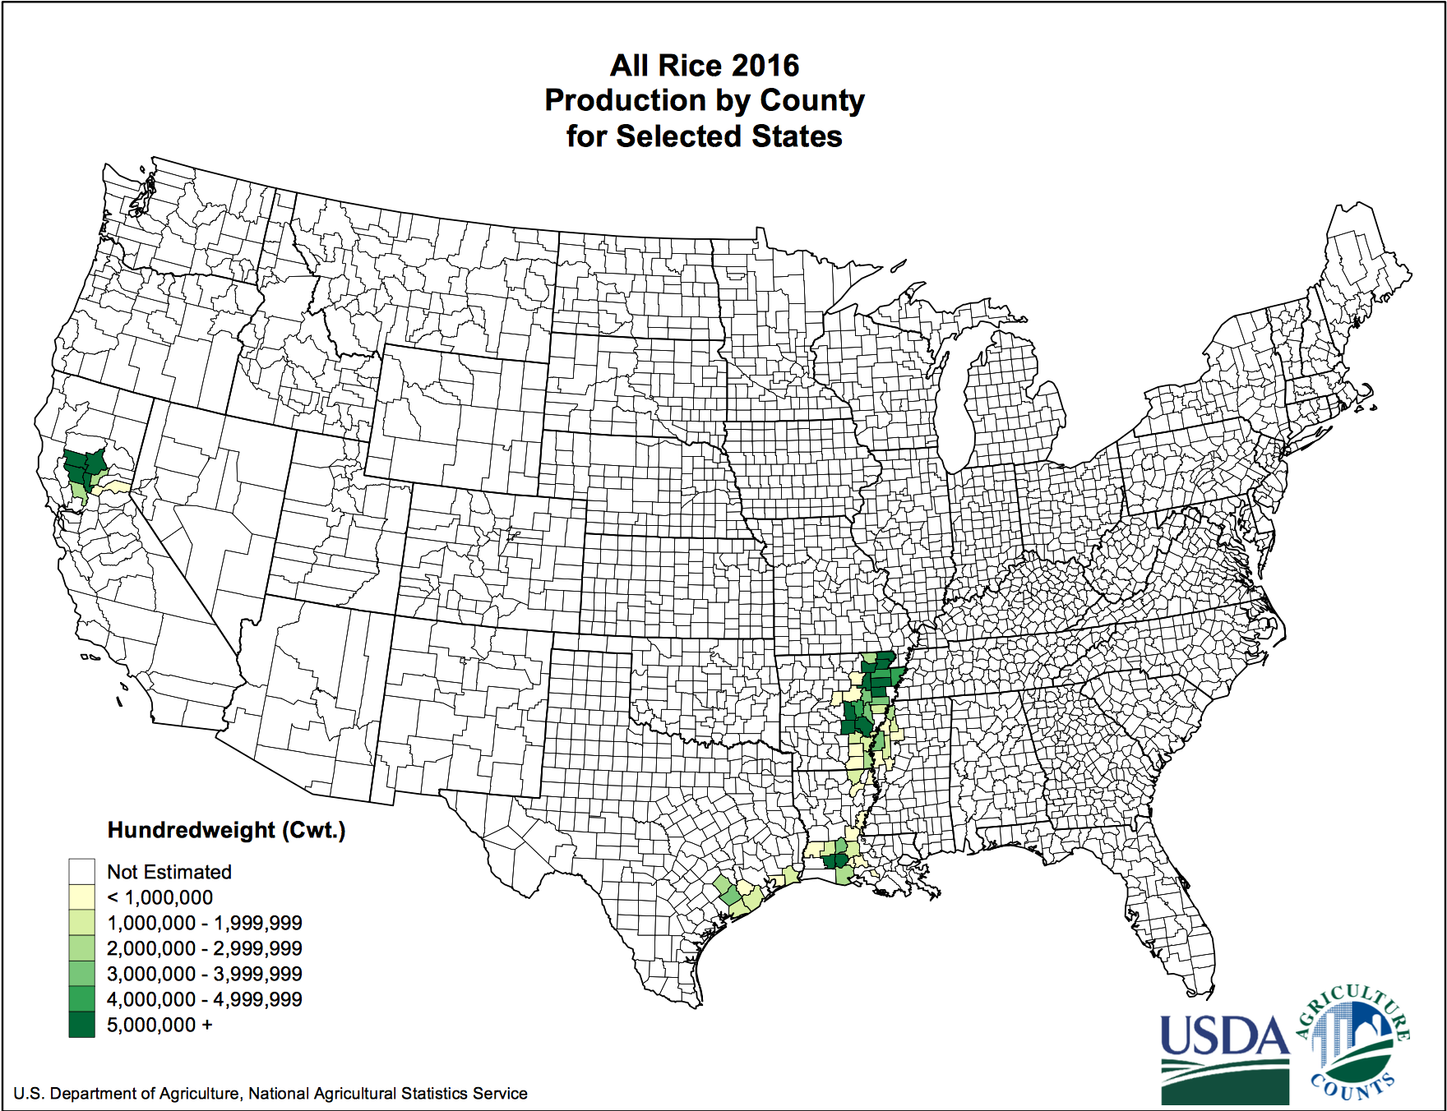

Resource #8:

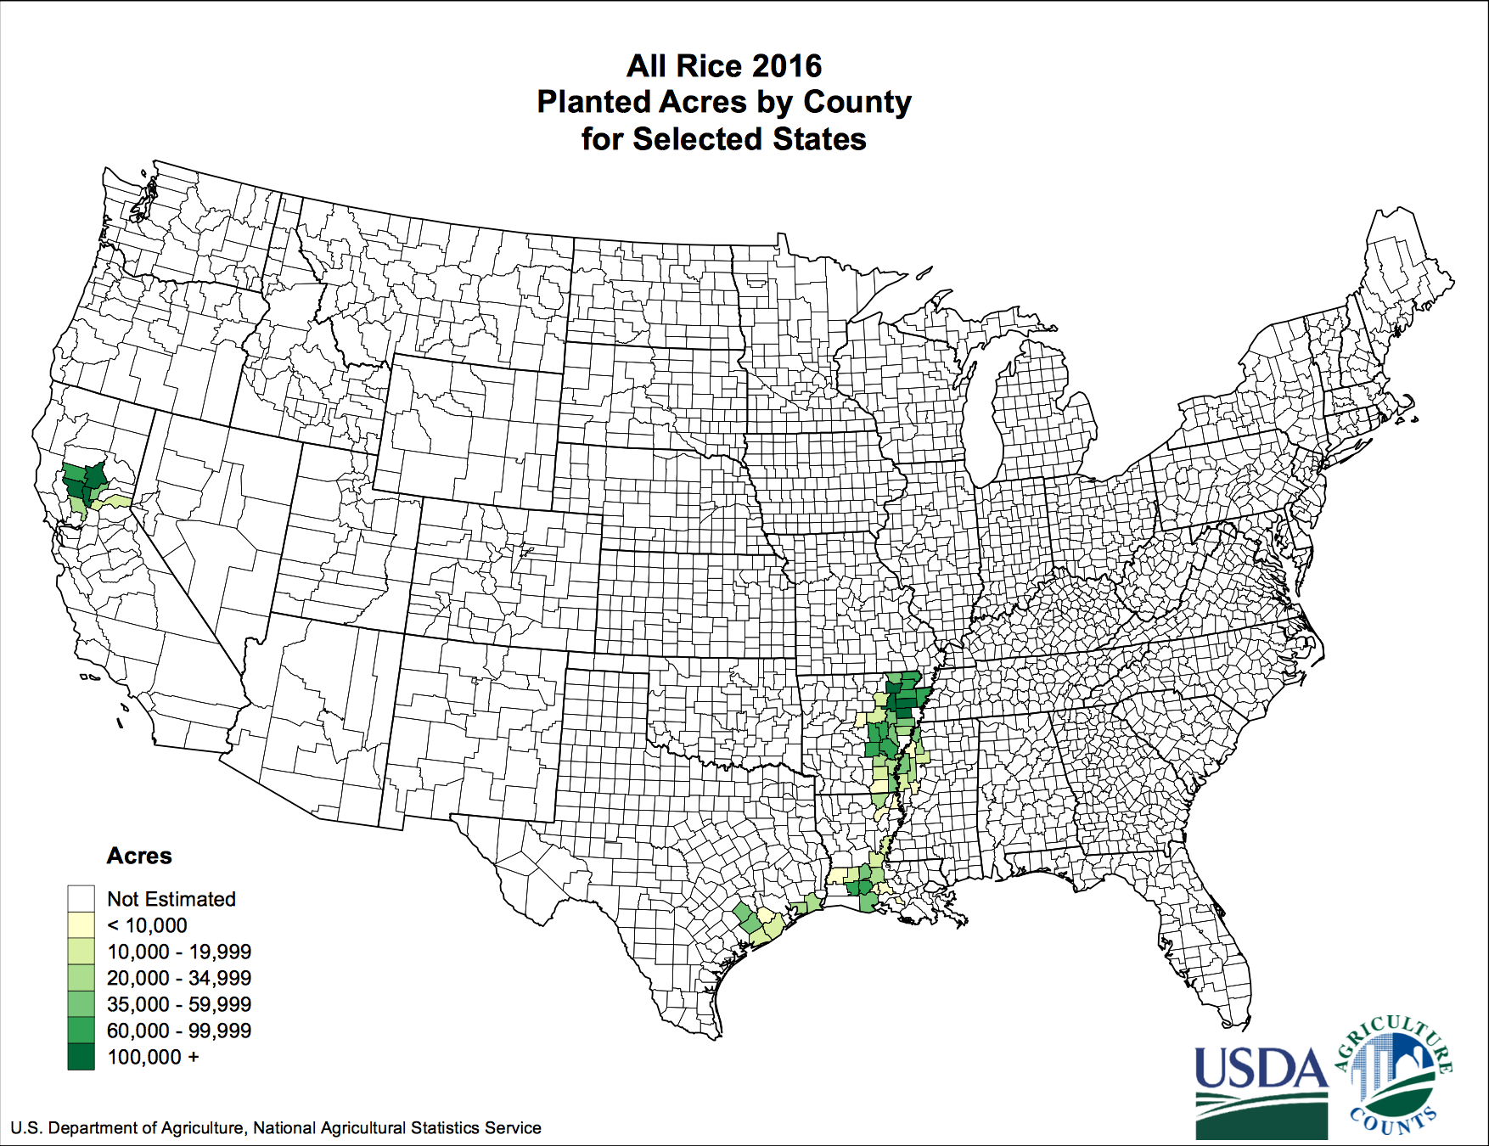

Resource #9:

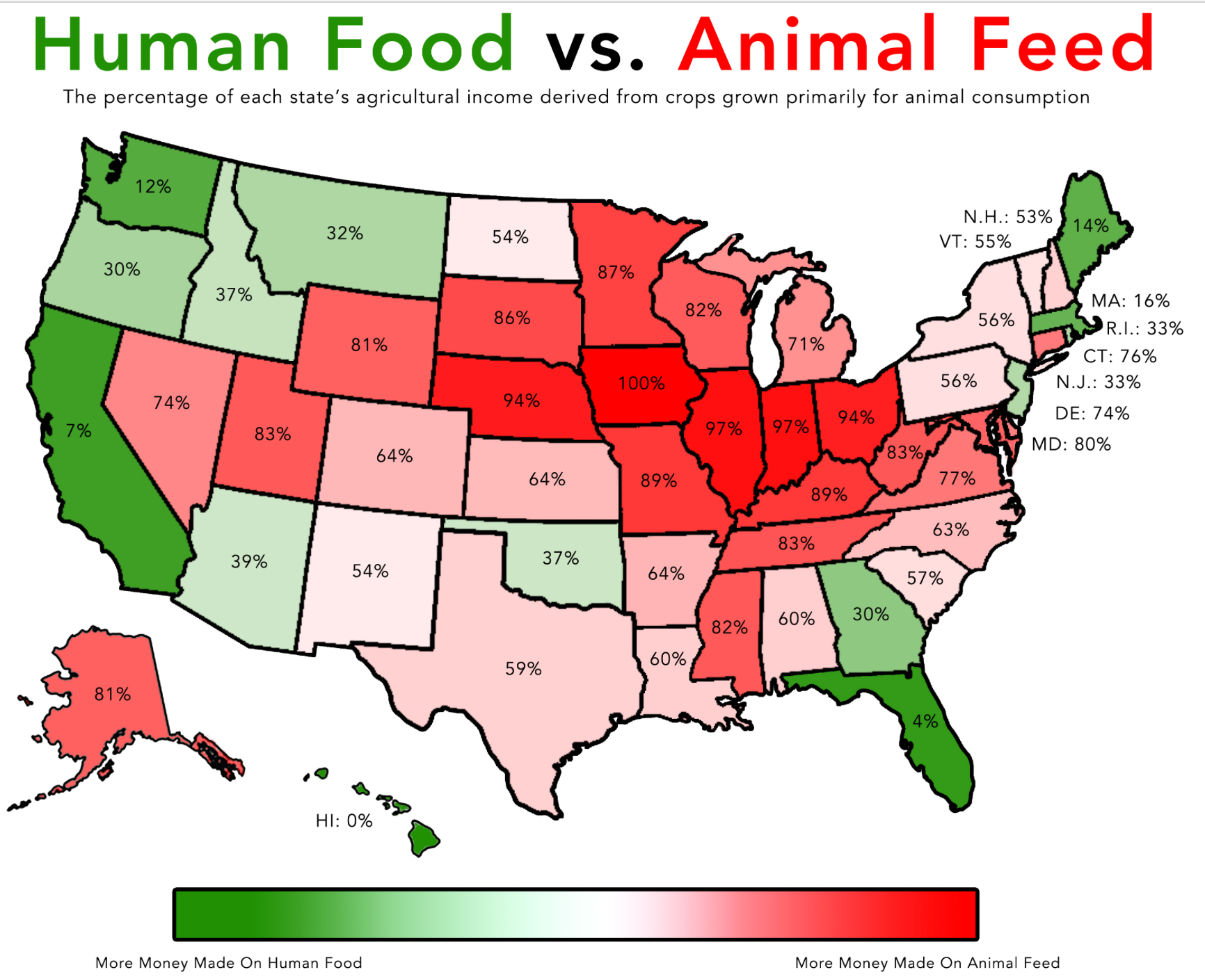

Resource #10

