Cultural Landscapes of South Korea: Material Reflections of Nonmaterial Culture

Author
Doug Andersen
Oak Canyon Junior High School, Utah
dandersen@alpinedistrict.org

Doug Andersen has been teaching Geography in the public schools for over 25 years. He received a Bachelor’s degree in Secondary Education Social Science Teaching from Brigham Young University with minors in Geography, History, and Anthropology. He later received a Master’s degree from Utah State University in Geography focusing on incorporating the concept of cultural landscapes in the high school geography curriculum. He has taught World Geography, World History, United States History, and Advanced Placement Human Geography. He has also coached and advised many clubs and teams. Doug completed a two year assignment in the McKay School of Education at Brigham Young University where he taught social science teaching methods and supervised student teachers.

Doug loves to discover the world through travel. He developed a special interest in Asia after serving as a Christian missionary in the Philippines for two years. He has presented and chaired many teacher workshops and institutes.

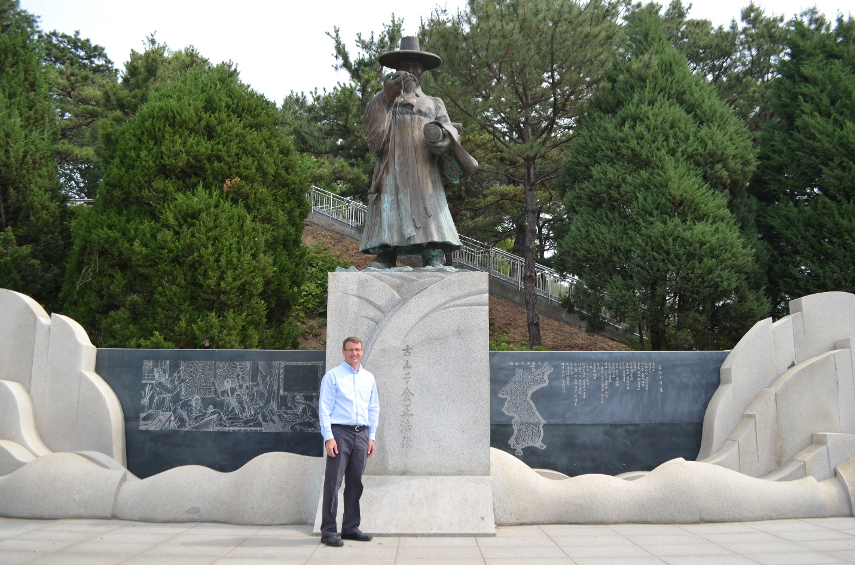
Cultural Landscapes of South Korea: Material Reflections of Nonmaterial Culture

Author:
Doug Andersen
Oak Canyon Junior High School
Lindon, Utah
dandersen@alpinedistrict.org

Abstract: Students use a variety of primary and secondary sources including the new National Atlas of Korea Vol. III to investigate the changing cultural landscapes in South Korea. Students analyze statistics and images to make hypotheses about the changing culture of South Korea as reflected on the cultural landscape.

Grade Level: 9-12

Subject: AP Human Geography

Time Required: 1 class period

Essential Understandings/Learning Objectives/Essential Knowledge:
- Field experiences continue to be important means of gathering geographic information and data. (Topic I, E)
  - Use quantitative and qualitative geographic data.
    - Data may be gathered in the field by organizations (e.g., census data) or by individuals (e.g., interviews, surveys, photography, informal observations).
- Concepts of culture frame the shared behaviors of a society. (Topic III, A)
  - Explain the concept of culture and identify cultural traits.
    - Cultural traits are individual elements of culture and include such things as food preferences, architecture, and land-use.
- Culture varies by place and region. (Topic III, B)
  - Explain cultural patterns and landscapes as they vary by place and region.
    - Regional patterns of language, religion, and ethnicity contribute to a sense of place, enhance place making, and shape the global cultural landscape.
    - Language, religion, ethnicity, and gender are essential to understanding landscapes symbolic of cultural identity (e.g., signs, architecture, sacred sites).
  - Explain how culture is expressed in landscapes and how land and resource use represents cultural identity.
    - Cultural landscapes are amalgamations of physical features, agricultural and industrial practices, religious and linguistic characteristics, and other expressions of culture (e.g., architecture).

Resources needed: Projector and PowerPoint Presentation

Background: The culture of a group of people is reflected in material and nonmaterial culture. The things that people make reflect the values and beliefs of their culture. Likewise, the changes people make to the natural landscape that reflect the values and beliefs of the culture is called a cultural landscape. By carefully examining the landscape, one can learn about the culture of the people who made the landscape.

Vocabulary:
acculturation
cultural landscape
cultural trait
material culture
nonmaterial culture
folk culture
popular culture
built environment

Anticipatory Set: Show picture of the Christian church in the PowerPoint presentation (Slide 1). Have students examine the photograph and identify which world region they think the photograph was taken (students can use the map from the AP Human Geography Course Description, Topic I [page 16] to identify the name of regions; for example, Latin America or Western Europe). Show the next slide (Slide 2) and have students examine the photograph in a smaller scale. Ask if this gives any additional insight as to where the photo was taken. The next slide (Slide 3) has two sections of the photograph enlarged to show detail. Ask if these details help identify that the picture was taken in the East Asia Region (South Korea). Explain that in this lesson, they will learn how the landscape of places can reveal the culture of the people who live there.

Procedures:

- (Slide 4—Title Slide) Explain that culture is reflected in both ideas and objects and that culture can be studied through material and nonmaterial culture.

- Slide 5 gives an overview of the essential questions of the lesson?

- Review definitions of nonmaterial and material culture on the next slide (Slide 6).

- Show the next slide (Slide 7), with a picture of figures on the roof of a palace building. Have students hypothesize what the animal like figures could mean. The sculptures, called Japsang, were thought to ward off evil spirits, and were also used to signify the importance of a building - the more Japsang on a roof, the more important the building. (http://www.cha.go.kr/cop/bbs/selectBoardArticle.do?ctgryLrcls=CTGRY206&nttId=58091&bbsId=BBSMSTR_1203&mn=EN_05_01)

- Students should copy the definition of cultural landscape as defined by Carl Sauer in their notes (Slide 9). He is considered by many to be the “father” of American cultural geography. But since the definition is from 1911, it needs a modern translation. Explain that just as artifacts found by archeologists can illustrate the beliefs or values of a culture, the changes people make to their natural environment can also show cultural aspects of the people who made the changes to the landscape. The way humans change the surface of the earth is called a "cultural landscape." Explain that each place on the earth is unique because of its physical and cultural characteristics. So even though two places may share similar physical characteristics, such as a tropical wet climate near the ocean, the two places could look very different from each other because of the culture of the people who live there.

- In the next slide (Slide 10), have students try to identify elements of difference in Korean cultural by observing the material culture. Observations might include that the language is written in a different script; there are different types of food, and the stall is in an open air market. Three video clips of the market are included (Slides 11-13)

- (Slide 14) Have students identify the similarities and differences between American and Korean culture in the pictures of baseball. Students might note that the Korean fans wear sports jerseys, like many American fans, that the stadium looks similar to American Stadiums, but that a cheer leading section is not common in American baseball. Students might find it interesting that in Korean Baseball, each player has his own song that the fans sing when he gets up to bat. The “Smile Guides” (Slide 15) blow their whistle to warn spectators of every foul ball that enters the seating section. Show the video of a player or team song led by cheerleaders (Slide 16). Each team brings their own set of cheerleaders and songs that are unique to the team. (For more information, see articles such as https://www.afar.com/magazine/why-korean-baseball-fans-are-better-than-american-fans; https://abcnews.go.com/International/inside-south-korean-baseballs-elaborate-cheer-culture/story?id=50817262 ).

- In the next slide (Slide 17), discuss the quote from American geographer Peirce Lewis. He developed “axioms” to help professors teach their students learn how to “read” a cultural landscape. Two noteworthy points are 1) Our every-day landscape indicates a great deal about our culture, but we need to be trained in what to look for. The lesson guides students through some images, graphs, and maps of South Korea to help students learn how to “read” cultural landscapes-to find the possible meaning in the recognizable changes people make to the natural landscape. In addition, Lewis pointed out that 2) Our landscape is more honest about who we are than many of the things we write about ourselves. Ask students why that may be. You may point out that the things we write about ourselves (autobiographies) often delete the things that we don’t want to emphasize, but the landscape is there for everyone to see.

- The next slide (Slide 18) informs students that reading the landscape can be overwhelming. It is messy. The lesson guides students through a few carefully chosen features as an example. This exercise can help students learn how to read a variety of landscapes.

- Before showing the picture (Slide 19), have students respond to the question about what people drink in East Asia. They will most likely respond tea (if they know anything about East Asia). The first image is of a tea plantation in Southwestern Korea. The second is of a Coffee (and hot dog) shop South Korea. Explain that tea originated in China and spread to other East Asian nations. We would expect Koreans to drink tea as the main beverage. But one of the most obvious features of the landscape is the great number of coffee shops in South Korea.

- Explain that the National Atlas of Korea is a great resource to learn about the Korean Peninsula. Volume III focuses on the cultural aspects of Korean society. Show the graphs and maps from page 205 of the Atlas copied on Slides 20-24. Have students analyze the data and draw conclusions about coffee drinking illustrates the changing nature of Korean culture. (The National Atlas can be viewed and downloaded at http://nationalatlas.ngii.go.kr)

- Share the following text from the National Atlas to help students confirm or modify their hypotheses:

“The image of a worker clutching a take-out coffee during lunchtime in the central business district of a city is representative of daily life in urban areas. Coffee and tea-related culture has undergone rapid changes in Korea. The most recent typical phenomenon is the trend of buying freshly brewed coffee from a coffee shop. Recently, the number of coffee shops has been growing rapidly in cities, and franchise coffee shops are a common feature of the urban landscape. While the restaurant business is consistently expanding, the number of coffee shops is increasing at a higher rate. Coffee shops are also rapidly increasing in residential areas and suburbs as well as in the central areas of metropolitan cities.

“As a result, the variety and amount of coffee imports have steadily grown. Brazil and other Latin American countries, Vietnam and other Southeast Asian countries, and African countries such as Ethiopia are common sources of coffee bean imports. Since the mid-2000s, the number of coffee shops has increased rapidly, but the number of coffee shops being closed after the initial enthusiasm has also increased.”
(Coffee Volume III, page 205 )

- Discuss with students the importance of quantitative and qualitative geographic data. Field work is an important part of human geography. While the graph quantifies the use of coffee, qualitative data from the field is important, especially in analyzing the cultural landscape. As a personal anecdote, while traveling with a group of geography teachers in South Korea in 2017, we were accompanied by Dr. Greg Chu, a geography professor originally from Hong Kong. He and his wife preferred to drink hot tea, but on several occasions, the restaurants we visited did not even serve hot tea.

- Slide 25-26 confirm on the ground, the changing societal preference for coffee on the landscape with both international chains and local coffee shops.

- Explain to students that Peirce Lewis taught that when we observe changes in the cultural landscape, those changes correspond to changes in the culture of the society. You may ask students what changes they have noticed on their local landscape that might indicate a change in the culture (i.e. “quick” loan stores, new businesses, closed businesses, etc.)

- Peirce Lewis explained that changes in the landscape indicate changes in the culture (Slide 27)

- The National Atlas of Korea, Vol. III also discusses the changing food preferences in South Korea. Have students exam the picture of “traditional” Korean food from the Atlas and the graph (Slide 28). Students should note that rice consumption has decreased over time, while meat and dairy has increased. Have students predict how this change might be reflected in the cultural landscape.

- Have students analyze the graph and maps on slides 29-32, Read the following text from the National Atlas to help students confirm or modify their hypotheses:

“The fastest growing type of restaurant in Korea is the chicken restaurant, due to the suitability of chicken dishes for fast food and delivery and the cultural popularity of “chicken and beer.” Recent analysis of public data reveals that more than 30,000 chicken restaurants were in operation across the country at the end of 2014. As the Korean economy has entered a low-growth phase with related unemployment, chicken restaurants have emerged as an easy start-up business due to the standardized and relative ease of meal preparation. In addition, in 2014 alone, as many as 4,000 chicken restaurants opened, with a number of chicken restaurants also shutting down due to intensified competition. Thus, the failure rate for chicken restaurants is high.
(Chicken Volume III, page 207)

- Show slides 33-35 to show how this change is reflected on the landscape of South Korea. Chicken and Beer has become a comfort food in S. Korea and is called chimaek--"chi" for chicken and "maek" for maekju, Korean for beer. (Another informative source is https://www.cnn.com/travel/article/south-korea-beer-chicken/index.html )
- Slide 36 Shows an example on the landscape of both a coffee shop and chicken restaurant. Both are US chains. Discuss if US chains really show a change in Korean culture.

Assessment:

- Now that you have modeled “reading” the cultural landscape with students, students will try it on their own with the next two slides (Slides 37-39). Instruct students to write a short paragraph that
1) describes the landscape (what they see)
2) analyzes the landscape (what they think it means or shows about changing Korean culture).

- Discuss student’s interpretations of the landscape. You may need to clarify that a cat café does not serve cat, but that while people have a snack or drink at the café, they can play with the cats. Either for an entrance fee that includes a drink (coffee?), or just a coffee lounge, people come to play with or watch the cats. They also sell cat snack people use to feed the cats.

Some possible interpretations may include that Koreans may see playing with cats as a healthy way to relieve stress; they may not be able to have cats in their apartments; feel that leaving a cat alone all day is cruel; they may be so busy with school or work that relationships with humans are harder than spending time with cats; etc.

- Slide 40 is a restaurant in a tourist/beach location in Southeastern Korea (Haeundae Beach, Busan). Ask student to consider and discuss what makes this café similar or different from other landscapes in Korea.

Explain that English signs are often used in Korea, but this is different because of the complete absence of Korean signage seen from the street. Ask students to comment on whether they think this is an isolated case or if it might become a more common cultural element. If so, what might it indicate about changing Korean culture?

Conclusion

- Remind students of the 3 essential questions (Slide 41). Have students pair-share their answers.

- Slide 42 is a quote located in the ground floor of the G Tower, a skyscraper in Songdo International City, a new city built from scratch in on reclaimed land in the Incheon Free Economic Zone, South Korea. William Cowper was an 18th century British Poet. How does this quote explain the S. Korean view of the cultural landscape?

- Extension: If time allows, slides 43-48 show pictures of things that caught our attention while traveling through South Korea July 2017. Enjoy the fun and interesting culture of South Korea!

